California's drought: Getting grimmer, say experts

[Mark Koba](http://www.cnbc.com/id/15909660) | [@MarkKobaCNBC](http://twitter.com/MarkKobaCNBC)

3 Hours Ago

CNBC.com

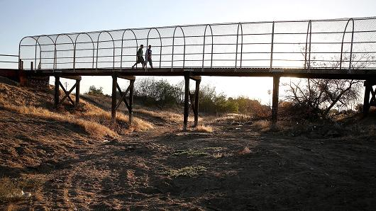

Getty Images

A footbridge spans a dry river bed in Porterville, Calif.

Every week, a government weather agency releases a report on the conditions of California's drought. And every week seems to bring grim news. The latest report is no exception.

[**The National Oceanic and Atmospheric Administration**](http://www.noaanews.noaa.gov/stories2014/20141016_winteroutlook.html) said Thursday that California's record-setting drought—heading into its fourth year—will likely persist or even intensify in large parts of the state.

"Complete drought recovery in California this winter is highly unlikely," said Mike Halpert, acting director of NOAA's Climate Prediction Center, in releasing the analysis.

"While we're predicting at least a 2 to 3 percent chance that precipitation will be near normal or above normal throughout the state, with such widespread, extreme deficits (in rainfall) the recovery will be slow," Halpert added.

**Beer leaves California high & dry**

Monday, 20 October 2014 | 10:53 PDT | 01:32

CNBC's Jane Wells reports the impact California's drought is having on the fast growing craft brew industry.

**Read More**[**If California doesn't get rain this winter ...**](http://www.cnbc.com/id/102057022)

The fact that the drought is nowhere near ending means the hard times will only get worse, said Michael Hanemann, an environmental economist at Arizona State University.

"Another dry winter will mean this is going into territory we haven't had before," said Hanemann. "We'll have even less water to distribute, putting more stress on the system," he said. "We'll likely have more severe water shortages next spring and summer."

**Record low for rain**

There had been hope for heavy rains this winter. The weather condition known as El Nino was expected to bring strong rains to the state, but those projections have been toned way down.

Now NOAA predicts that even if El Nino does occur, it is expected to be weak with little rainfall.

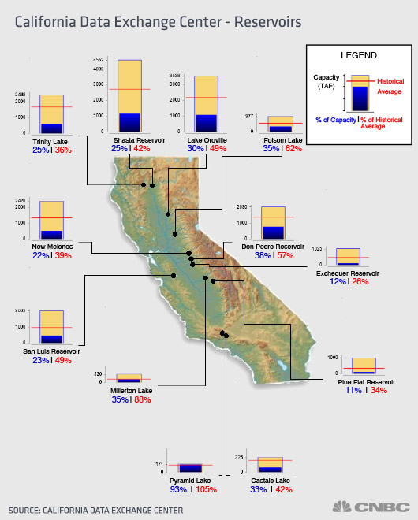

That prospect is coming on top of an already dire situation. This past year was the fourth-driest year ever for California based on rainfall and water runoff measurements. It got only around 60 percent of the yearly average precipitation.

**Read More**[**Trees vs. humans: In California drought, nature gets to water first**](http://www.cnbc.com/id/102094056)

While most of the state's reservoirs are at nearly 59 percent capacity, water supplies in the three largest reservoirs are at only about 30 percent of capacity. Other water sources are also drying up.

"Groundwater demand is normally around 40 percent a year," said Doug Carlson, information officer at the California Department of Water Resources (DWR). "Now it's at 60 percent demand."

**Crops, growers suffering**

Crops feeling the heat from the California drought include, hay, wheat, olives and corn. Livestock deaths have increased because of the lack of water in the state.

Rice production also has been hit, with nearly 25 percent of the state's $5 billion rice crop likely to be lost this year due to lack of water, experts said.

**Read More**[**California rice farmer: Drought may make us 'quit'**](http://www.cnbc.com/id/101984473)

Dairy production is also down. California, which is the top milk producer in the U.S., has lost 1 percent to 2 percent of its dairy industry because of the drought in the last three years, [**according to recent statistics.**](http://www.timesleader.com/news/business/50461016/California-dairy-farmers-struggling-to-survive-prolonged-drought)

The falloff in crop and livestock production from the drought—along with increased costs for groundwater use—is expected to cost California $1.5 billion this year, according to [**a report from the University of California, Davis.**](https://watershed.ucdavis.edu/files/biblio/DroughtReport_23July2014_0.pdf) Some 17,000 seasonal and part-time jobs will also be lost.

An estimated 420,000 acres of farmland went unplanted this year—about 5 percent of the total in the state. The entire statewide economic cost of the 2014 drought is paced at $2.2 billion.

Even the state's pumpkin growers are facing problems from the lack of rain. Next to Illinois, California is the second-largest pumpkin producer in the country.

"The impact is very severe on us, and if we don't get rain this winter we won't be able to grow anything," said Wayne Martin, a farmer in Fresno, California, who grows pumpkins on his 60 acres of land.

"It's very bad here with the little water we have," he said.

Residents, too, are feeling the pain. Some 500 people in Tulare County, in the central part of the state, cannot flush a toilet, wash clothes or drink water out of the tap because water sources have dried up.

**Hope experts are wrong**

Efforts to contain the drought include tougher water restrictions and new laws to contain the use of groundwater supplies, something farmers have turned to more and more as surface water sources have dried up.

To try to curtail the drought's effects, California started implementing fines statewide this summer of as much as $500 for watering lawns and washing cars.

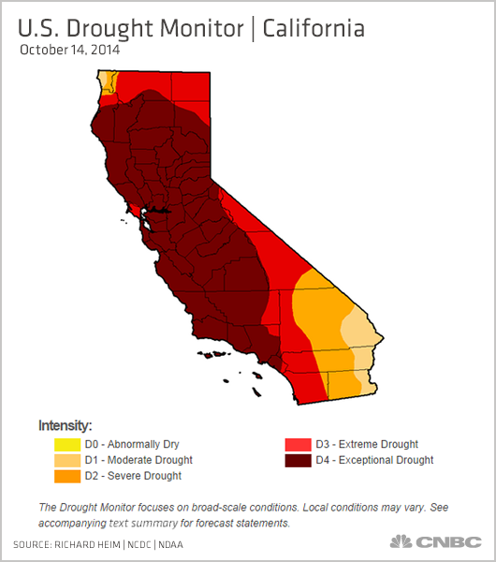

Voters in California have a chance to approve a $7.2 billion bond issue this November that's aimed at providing water storage and delivery to drought-stricken cities and farms.

**Read More**[**California drought's new target: The great pumpkins**](http://www.cnbc.com/id/102083439)

"The bond should help, but relief won't happen over night," said ASU's Hanemann. "It will take time to work out the details and implement."

In the meantime, those in California hope the weather experts are wrong.

"All we can do is pray for rain," said pumpkin grower Martin.