**Burger King's french fry challenges continue**

*By:* [*Bruce Horovitz*](http://americasmarkets.usatoday.com/author/bhorovitz/) *August 13, 2014 5:34 pm***EMAIL**

Looks like Burger King’s much-hyped Satisfries didn’t fully satisfy.

[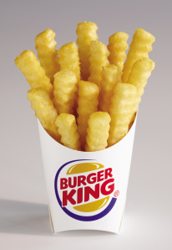](http://americasmarkets.usatoday.com/2014/08/13/burger-kings-french-fry-challenges-continue/xxx-bk-lo-cal-fries-jpg/#main)

In a terse statement on Wednesday, Burger King ([BKW](http://www.usatoday.com/money/lookup/stocks/BKW/)) said that the majority of Burger King franchisees have opted to stop selling the lower-calorie fries that were rolled out with much fanfare late last year.  But some 2,500 restaurants in North America will continue to sell them.

Part of the problem:  They are pricey.   A small order of the lower-calorie fries typically costs about $1.89 vs. $1.59 for a bag of its regular fries.

“At launch, Burger King Corporation announced that guests would ultimately determine how long Satisfries would remain on the menu,” said Alex Macedo, president of Burger King North America, in the statement.

Earlier this week, franchisees were given the option to keep them — or dump them.  The majority opted to drop them — and some have begun to phase them out already.

Satisfries are made with a special batter that absorbs less oil — and claim to have 20% fewer calories than conventional BK fries. A small serving of BK’s Satisfries weighs in at 270 calories and 11 grams of fat vs. 340 calories and 15 grams of fat for a small serving of its classic fries.

But, once again, it appears Burger King has chalked up yet another french fry flop.  For decades, it has tried but failed to create a french fry that matches or exceeds the holy grail of fries: McDonald’s.

Never mind the BK’s stock closed up about 1% on Wednesday.

It’s back to the frying board.