# PROTEIN ALTERNATIVES

The first quarter of 2014 has seen prices for cuts of beef such as rib eye, strip loin, and tenderloin increase more then 10% over 2013. This trend appears set to continue as 1st quarter prices for feeder cattle are up 20% over last year. As the prices for proteins continue to increase we look to cost effective alternative cuts to help maintain food cost goals.

We make the following alternative cut suggestions. We have seen many of these cuts referred to on menus as “Artisan” or “ Butcher Block” cuts. We suggest using daily specials to offer the specialty cuts, as this will allow servers to tell a story about the cut since some guests may not be familiar with the names.

Vendors may need 24-48 hours advance notice to procure some of these cuts since there is typically not enough consistent volume to necessitate keeping them in stock. The item can be advanced ordered and offered as a special when it becomes available from the vendor.

Please coordinate with your Program vendors to arrange for samples. Where applicable, the Meat Buyer’s Guide (MBG) number is included. *The prices indicated may vary due to market fluctuations, product availability and weather conditions.*

# - BEEF CUTS -

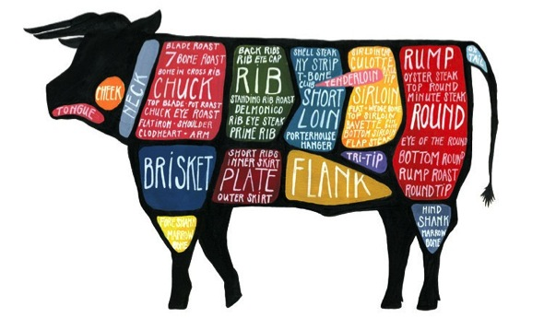

# CHUCK SHOULDER

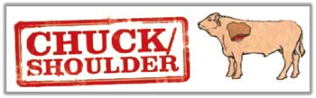**CHUCK SHOULDER –** The chuck primal cut extends from the neck to the fifth rib and includes the shoulder blade and upper arm. It is often divided into two main sections, or sub-primals, known as the blade portion and the arm half. The chuck has plenty of connective tissues that melt when the meat is cooked. This helps to add flavor and also helps to tenderize the meat. Although chuck cuts are flavorful, they are not as tender as the loin and rib cuts. They can become rather tough if not cooked properly. Cuts from the chuck benefit from slow cooking using moist heat methods, such as braising but some cuts can be pan seared or grilled.

## Teres major | MBG 1114F

- **Choice:** $5.18/lb. – **Prime:** $5.65/lb. – **Waygu:** $8.70/lb.

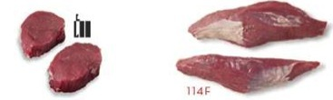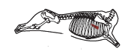

**Teres Major –** The Teres Major is a cone shaped muscle next to the top blade. This cut also known as “bistro”, “petite”, **“**mock”, or shoulder tenderis often carved into medallions. Cut from a muscle in the chuck shoulder *(114F)*, it is the second-most-tender cut of beef. *(Tenderloin being the most-tender cut)* The individual steaks are prepared by a straight cut across the grain. Like tenderloin, teres major is incredibly lean and benefits from added flavoring, such as a bacon wrap, compound butter or a brush-on grill sauce. The best use for this cut is pan searing or grilling, then cutting into medallions.

## Flat Iron | MBG 114D: PSO-1

- **Choice:** $7.23/lb. – **Prime:** $7.67/lb. – **Waygu:** 11.20/lb.

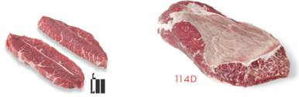

**Flat Iron** – This cut comes from the top blade right above the teres major and is composed of two muscles joined by a layer of soft fat. One of the two muscles that form the steak is the teres minor, which rivals the teres major in tenderness. The flat iron steak with the tissue or tendon removed *(114D: PSO-1)* is generated from the top blade muscle *(114D)*. Although the fat doesn’t look appetizing on the raw steak, it melts during cooking, basting the meat throughout the grilling process. The added fat as well as a good amount of marbling gives the flatiron steak more flavor than the teres major. Its flat thin shape means it should not be cooked beyond medium-rare; cooking it to medium can result in a tough steak.

## Shoulder Clod Heart “Ranch” Steak | MBG 1114E

- **Choice:** $6.07/lb. – **Prime:** $6.60/lb. – **Waygu:** $8.39/lb.

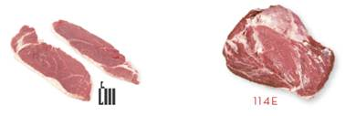

**Shoulder Clod Heart–** Typically called a “Ranch” Steak the technical industry name is “boneless chuck shoulder center cut steak” *(1114E)*. The Ranch steak is cut from the cleaned clod heart *(114E: PSO-1)* and is sliced across the grain.It is usually cut no thicker than one inch, weighs ten ounces or less, and is usually trimmed of all fat. Since it is from the chuck primal, it is very flavorful, but can be a bit tough. The best results are achieved if the steak is not cooked beyond medium when using dry heat cooking methods. It is best when it is braised, however it is excellent when grilled, broiled, or pan-fried if it is marinated first and if it is not overcooked.

## Chuck Flap “Denver” Steak | MBG 1116G

- **Choice:** $6.07/lb. – **Prime:** $6.60/lb. – **Waygu:** $8.39/lb.

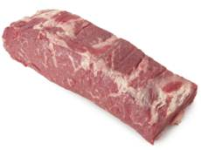 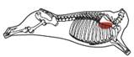

**Chuck Flap –** The “Denver” Steak *(1116G)* is an exceptionally marbled steak that is cut from the upper portion of the chuck roll *(116A)* and renders itself to be a very tasty smaller size steak. The technical industry name is “under blade center cut steak”. The steak is cut from the chuck flap thus giving it that flat square shape. A continuation of the short rib from the chuck, it is well marbled, with good distribution of fat, and easily grilled. In an extensive study conducted at the Universities of Nebraska and Florida for the United States beef industry, the Denver steak ranked 4 of 40 in tenderness, just behind rib eye.

# SIRLOIN

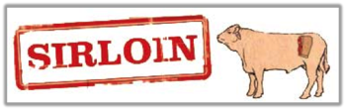**SIRLOIN –** The sirloin is contained within the primal cut known as the loin. The loin is divided into two sections known as the sirloin and the short loin. The sirloin and short loin may be considered two separate primal cuts or they may be considered parts of the whole. The sirloin is located between the short loin and the round and includes the hip section and ends at the socket of the pelvis.Cuts from the sirloin are flavorful and tender, but they are a bit less tender than cuts from the short loin. Cooking methods such grilling, broiling, frying, and roasting are used to prepare cuts from the sirloin.

## Tri-Tip | MBG 1185C

- **Choice:** $9.10/lb. – **Prime:** $9.91/lb. – **Waygu:** $17.40/lb.

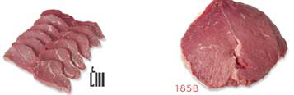

**Sirloin Tri-tip** – The tri-tip steak comes from the bottom of the sirloin primal cut and is triangular in shape, giving it three points or tips. The steak can be made into specified portions by slicing the tri tip at an approximate right angle to the grain direction of the muscle fibers. Before the 1950s, the tri-tip was sliced into individual steaks before cooking or made into ground beef. Grillers in Santa Maria, Calif., made it a staple by rubbing it with a mixture of seasonings and cooking it over red oak, common in the region. On the East Coast, a steak cut from the tri-tip is commonly referred to as the “Newport” steak. This lean flavorful cut is extremely tender when cooked correctly. Best suited for the grilling or dry over roasting.

## Top Sirloin Butt Steak “Baseball Cut” | MBG 1184F

- **Choice:** $11.02/lb. – **Prime:** $11.66/lb. – **Waygu:** $13.83/lb.

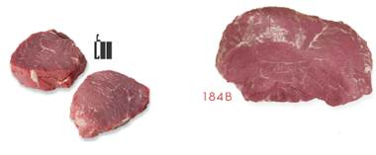 

**Sirloin Butt Steak –** These steaks also referred to as a “baseball cut” are prepared from a top butt *(184F)*. These steaks are cut from the center muscle in such a way they look just like a tenderloin filet – taller and rounded in shape. The baseball cut is an excellent alternative steak to the filet for economical banquet applications especially duo plates, as well as a unique stand-alone entree.

## Bottom Sirloin Flap Steak | MBG 1185A

- **Choice:** $7.79/lb. – **Prime:** $9.44/lb. – **Waygu:** $19.80/lb.

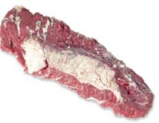 

**Sirloin Flap –** Sirloin flap meat also known as sirloin tip comes from the beefy tasting bottom sirloin just above the flank and right next to the short loin. The flank steak is removed along with the layers of and the remaining meat is called flap meat. Not to be confused with chuck flap meat, which comes from the front of the animal. Sirloin flaps are an extension of the T-bone and Porterhouse steaks and flap meat is officially part of the short loin section. The cut is referred to in French as “bavette d'aloyau”. The sirloin flap steak is a cut similar to skirt, hanger and flank steaks.

# FLANK

**FLANK –** The flank is located on the underside of the animal below the loin primal. The brisket/plate/flank are often grouped together as one primal cut, or they may be considered separate primal cuts. The flank is used mostly for grinding, except for the long and flat flank steak best known for use in London broil and the inside skirt steak, also used for fajitas.

## Flank Steak | MBG 193

- **Choice:** $4.62/lb. – **Prime:** $5.04/lb. – **Waygu:** $9.80/lb.

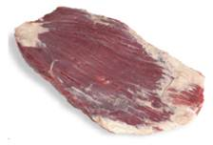 

**Flank Steak –** This cut is generated from the primal flank. Flank steaks were once one of the most affordable steaks, because they are substantially tougher than the more desirable loin and rib steaks. Many modern recipes for flank steak use marinades or moist cooking methods, such as braising, to improve the tenderness and flavor. This, combined with a new interest in these cuts' natural leanness, has increased the price of the flank steak.

# SHORT PLATE

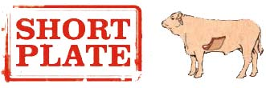**Short Plate –** The plate cut (also known as the short plate) is from the front belly of the cow, just below the rib cut. The short plate produces types of steak such as the skirt steak and the hanger steak.

## Inside Skirt Steak | MBG 1121D

- **Choice:** $6.78/lb.

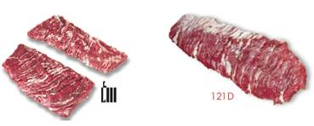 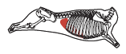

**Inside Skirt Steak –** The inside skirt steak *(MBG 1121D)* contains a lot of marbling and connective Tissue and is consequently a flavorful but tougher cut. Inside skirt steak is a bit thinner, stringier and more uneven than Outside Skirt Steak and generally costs less.

## Outside Skirt Steak | MBG 1121E

- **Choice:** $14.52/lb. – **Prime:** $22.62/lb. – **Waygu:** $23.20/lb.

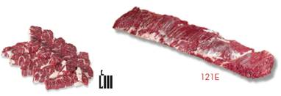 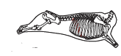

**Outside Skirt Steak –** These steaks are prepared from the outside skirt diaphragm muscle to meet the end requirements for item 121E. It is situated across the ribs, which extend from the end of the brisket. This long and thin cut is called Fajitas in Spanish meaning “little belts”. The outside skirt steak can be manually tenderized, rolled up, held with skewers and merchandized as London Broil or sold as 2 roughly 8 ounce (226.8 g) steaks which may be labeled “Bistro Steaks.”Outside Skirt Steak is a bit thicker, less fatty and stringy and more uniform than inside skirt steak, consequently outside skirt steak generally costs more.

## Hanger Steak | MBG 1140

- **Choice:** $6.77/lb.

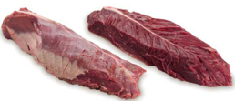 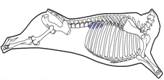

**Hanger Steak** – This cut is also know as hanging tender as well as a Butchers’ Steak because some butchers would keep it for themselves before it became popular. This long narrow muscle hangs off the kidney over the plate; hence the name. A hanger steak is a cut prized for its flavor and resembles flank steak in texture and flavor. It is a vaguely V-shaped pair of muscles with a long, inedible membrane down the middle. The hanger steak is usually a tender cut on an animal and is best marinated and cooked quickly over high heat (grilled or broiled) and served rare or medium rare, to avoid toughness.

# LAMB CUT - *Recommendations*

The first quarter of 2014 has also seen a significant increase in the price of Ccuts of lamb such as the rack and loin have increased X% over 2013. We make the following alternative cut suggestions.

Please coordinate with your Program vendors to arrange for samples. Where applicable, the Meat Buyer’s Guide (MBG) number is included. *The prices indicated may vary due to market fluctuations, product availability and weather conditions.*

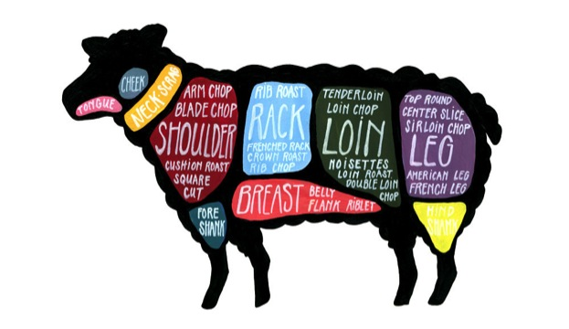

## Lamb Loin Chops | MBG 1232A

- Price: $9.77/lb.

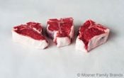 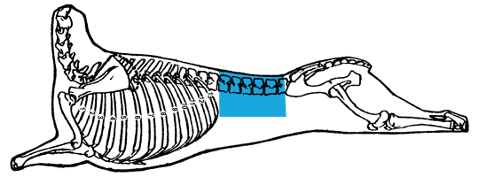

**Lamb Loin Chops –** This cut is the “porterhouse” of lamb and is comprised of the tenderloin and strip. Loin chops are among the most-tender meat cuts on the lamb. Lamb loin chops preparations include broiling, grilling, or panfrying and cook best if they're thick.

## Lamb Breast “Denver Style” Ribs | MBG 209A

- Price: $4.86/lb.

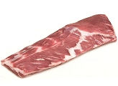 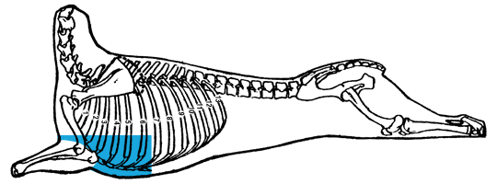

**Lamb Ribs –** This cut is from the lamb breast primal and consists of at least 7 ribs. This item is sometimes been referred to as “Denver Style Ribs.” Lamb ribs are a tender and abundantly flavorful cut. Lamb rib preparations include roasting, braising, and grilling and can be used in the same applications as pork ribs.

## Lamb Breast Boneless “Bacon” | MBG 209A

- Price: $4.86/lb.

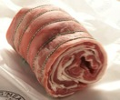 

**Lamb Breast Boneless –** Lamb breast can be deboned and cured into lamb bacon, which can be used in the same applications as pork bacon. The boneless breasts can also be rubbed with spices, stuffed and rolled into Roulade.

## Lamb Leg Steak “Cutlets” | MBG 1234A

- Price: $10.64/lb.

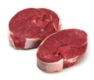 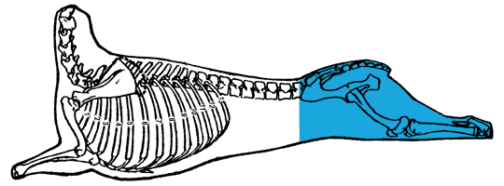

**Lamb Leg Steak –** This cut is from the from the sirloin portion of the lamb leg primal.

Lamb cutlets are quality, tender cuts of meat taken from the rack of lamb. Beautifully trimmed and lamb leg steaks are flavorful and ideal for grilling and frying.Flattening the steak into a cutlet before cooking is common.