Grade Inflation In The Maple Syrup Aisle: Now Everything Is An 'A'

by APRIL FULTON

January 30, 201411:33 AM 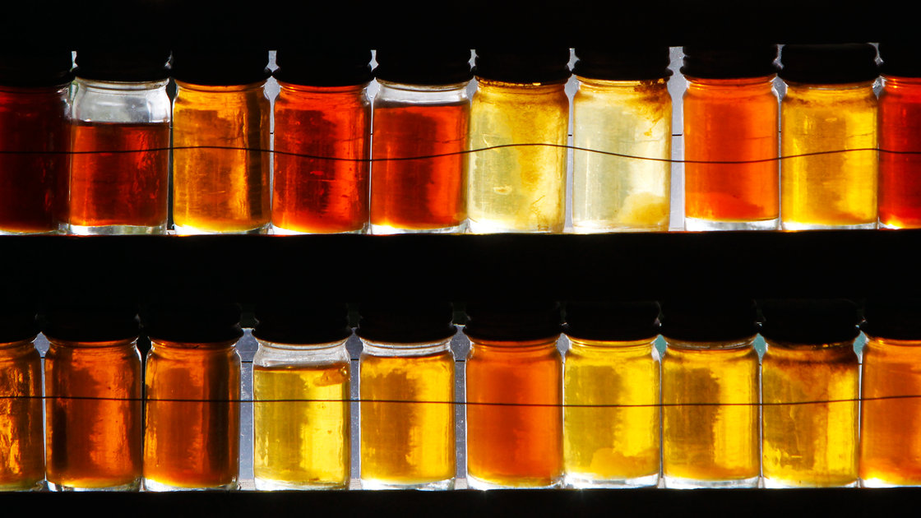

**It's All Grade A Now:** Different grades of maple syrup are displayed in East Montpelier, Vt.

*Toby Talbot/AP*

Why would you choose a B grade if you can get an A?

Ask a baker. They'll tell you that if you like richer, darker, more intense maple syrup, you should [pick Grade B](http://www.thekitchn.com/good-question-maple-syrup-grad-46292).

But the idea that B beats A seems counterintuitive to lots of consumers who are just looking for something sweet to pour on their morning pancakes. "Grade B just doesn't sound as good as Grade A," says Mathew Gordon, executive director of the [Vermont Maple Sugar Makers Association](http://vermontmaple.org/). Even though the system has been in place for decades, to many consumers, Grade B connotes "a less-than-perfect syrup," he says.

So this month, Vermont became the first state to give *all* syrup sold to consumers a grade of A, and require labels that are more descriptive of the syrup's flavor. For example, the lightest kind of maple syrup sold, "Grade A Light Amber," will become "Grade A Golden, Delicate Taste." Many bottles previously labeled "Grade A Dark Amber" and those labeled "Grade B" will become "Grade A Dark, Robust Taste."

Now, keep in mind that we're talking about real maple syrup, sold largely in beige plastic jugs from Vermont, the country's [largest producer](http://www.nass.usda.gov/Statistics_by_State/New_England_includes/Publications/0605mpl.pdf) of the stuff – not the cheap industrial bottles lining supermarket shelves and recently [banned](http://archive.chicagobreakingbusiness.com/2011/01/mcdonalds-to-serve-pure-maple-syrup-in-vermont.html) in Vermont's McDonald's restaurants.

Vermont is the first jurisdiction to put international efforts to unify maple syrup standards in place. It's important to develop one standard now that the industry is selling around the world and not just to its "next-door neighbors," says Gordon.

Consumers need to know what to expect. Canada currently uses a numbers grading system, and the New England states where syrup is produced each have their particular additional rules on thickness. But basically, the color descriptions have to do with how much light passes through the syrup, he says.

While some small syrup makers might harrumph about the government-mandated label changes, Gordon notes that many see the move as bringing their product in line with the rest of the world when it comes to coffee, beer, olive oil, and chocolate. All of those products have fans that seek out the darker, more intensely flavored versions.

[**Birch For Breakfast? Meet Maple Syrup's Long-Lost Cousins**](http://www.npr.org/blogs/thesalt/2013/09/28/226856804/meet-maple-syrup-s-long-lost-cousins)

"Over time, we've seen a trend with folks preferring the darker, stronger-flavored syrups, and so this will allow more of that type of product to be available to consumers," Emma Marvin, one of the owners of Butternut Mountain Farm, [told our colleague](http://digital.vpr.net/post/sweet-taste-grade-inflation) over at Vermont Public Radio recently.

And unlike grade inflation in schools, this doesn't mean they're now giving out higher marks for inferior work, maintains Butternut Mountain Farms, one of the state's biggest maple syrup producers.

"Removing the 'inferior' Grade B classification for the darkest syrups ... will allow people to make a decision based upon taste rather [than] perceived quality," the company says on its blog.

The new rules will also open up a whole new world of dark syrups to consumers. Up until now, syrups that didn't let enough light in (geek out over [here](http://www.maplesource.com/markets/industrial-market/maple-syrup/maple-syrup-grades.php) on light transmission percentages) couldn't be sold to the public — only to the food industry for granola bars and cereals and other processed products.

That's because decades ago, it used to be difficult to make a dark syrup that was still considered pure.

Now, unless there is an "off taste" — like a chemical aftertaste or bitterness from the sap of trees with too many buds, Gordon says — those syrups can be marketed as "Grade A Very Dark."