[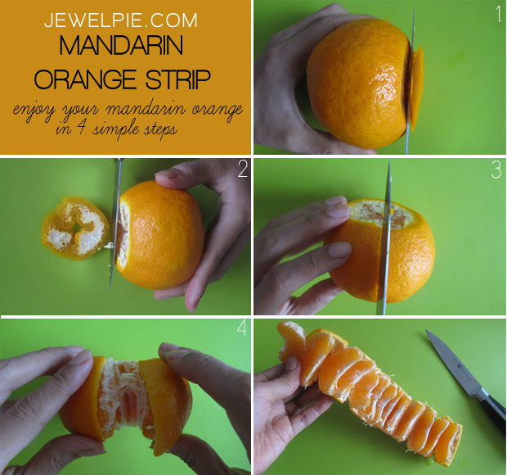](http://jewelpie.com/easy-way-to-peel-mandarin-oranges/)