Clementine:A variety of mandarin orange that was named in 1902. You may also know them as [Cuties](http://cutieskids.com/), which are marketed toward kids and are actually a cross between a clementine and a Murcott mandarin.

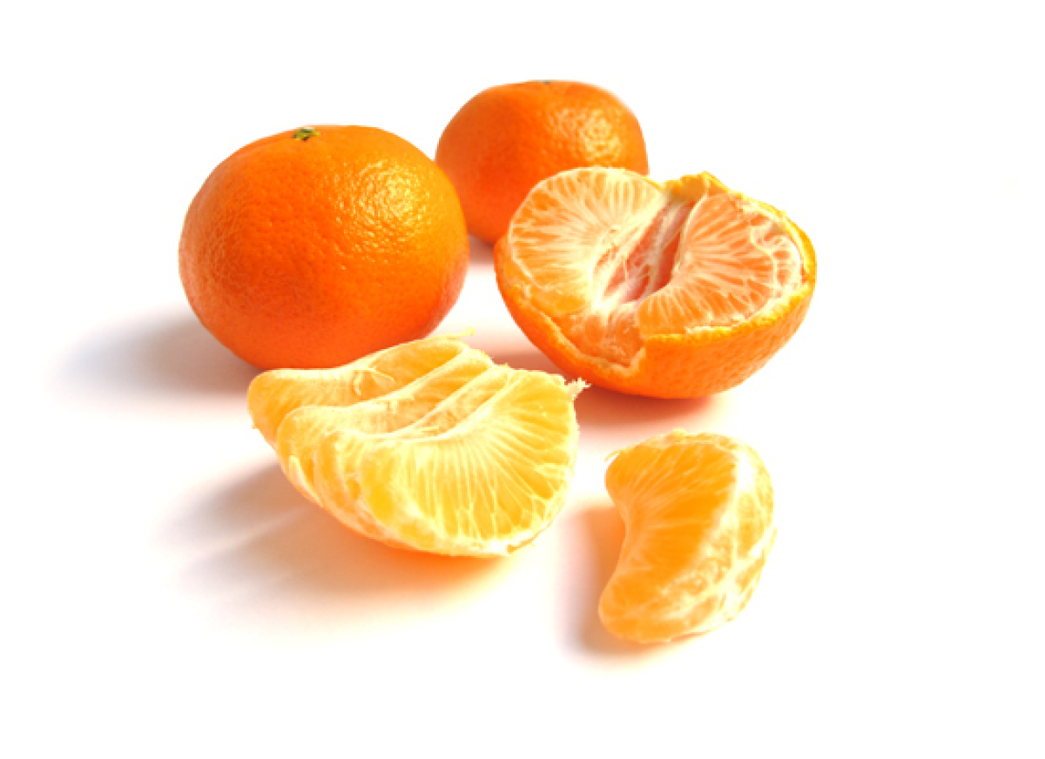

**Also Known As:** Seedless tangerine

**Available**: Mid-November through January

**Appearance:** Small, with a deep orange exterior that has a glossy appearance

**Qualities:** Easy to peel and almost always seedless. Clementines are sweet, with less acid than oranges, and are perfect for eating out of hand.

**Origin:** Morocco and Spain

**Our Tasters' Comments:** "Refreshing, sweet and tart." "I like the mellowness." "Surprisingly bland compared to the others -- I thought these would be my favorite." "Very mild flavor with some sweetness." "Lacks juiciness."

Tangerine: Closely related to the mandarin orange, the tangerine has been cultivated for over 3,000 years.

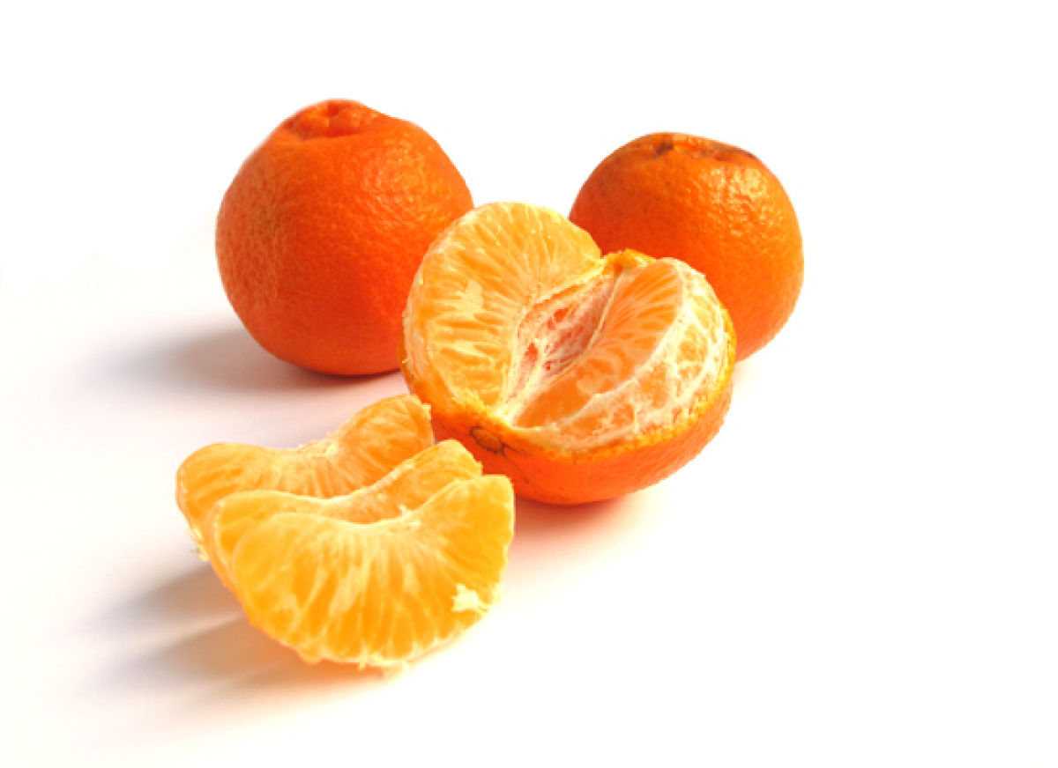

**Available:** October to April

**Appearance:** Smaller than most oranges, slightly soft, pebbly-skinned, and orange in color

**Qualities:** Tangerines are easy to peel and split into segments, but often have seeds (though the number varies from fruit to fruit). They're less tart and sweeter than oranges, and are good for eating out of hand.

**Origin:** China

**Our Tasters' Comments:** "Juicier than the clementine, with a distinctive taste." "Juicy and tart." "Similar to the clementine." "It's got a thicker white membrane than the clementine."

Honey Tangerine:Maybe surprisingly, since our editors weren't familiar with it, the honey tangerine is the most widely grown variety of tangerine.

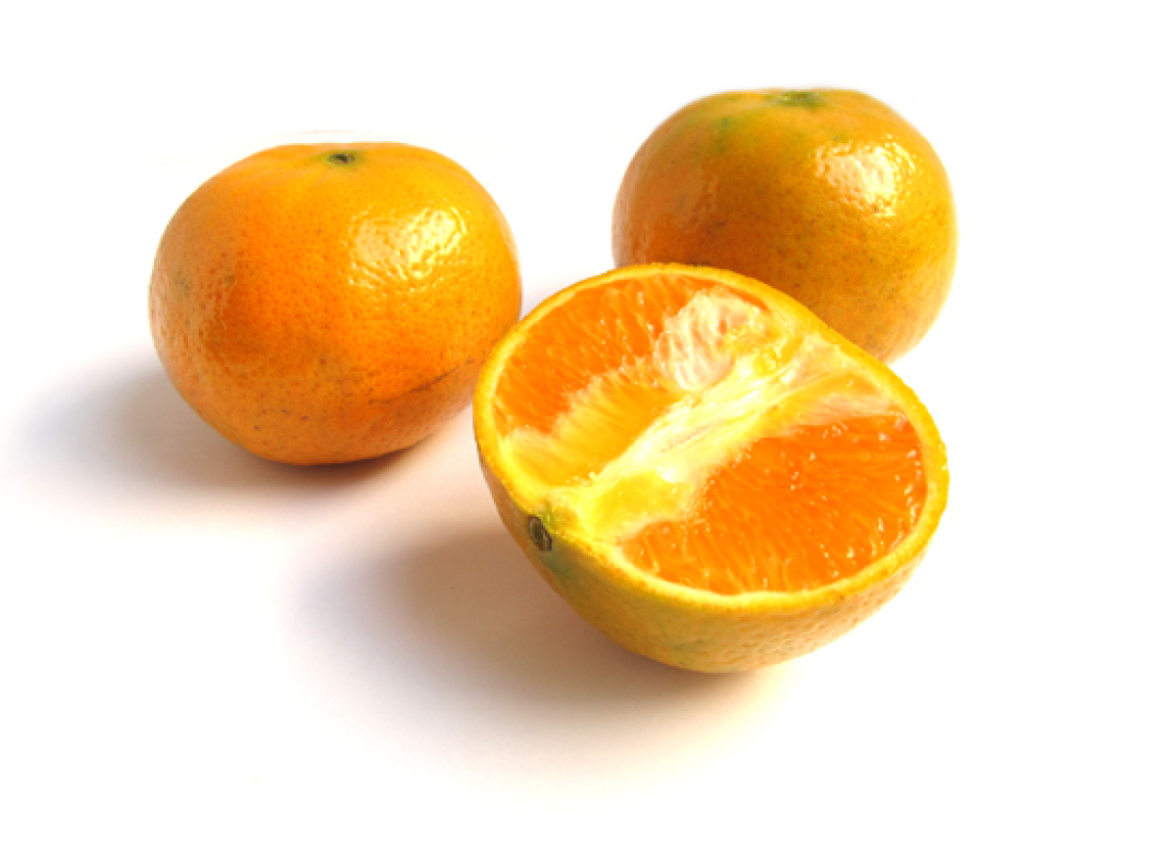

**Also Known As:** Murcott orange

**Available:** January to April

**Appearance:** The smooth, shiny and speckled skin can be colored either yellow-orange (in warmer winters) or orange-red (in colder winters).

**Qualities:** Honey tangerines have between 12 and 24 seeds on average, a tough skin (making it harder to peel), and a sweet, honey-like taste (hence its name). Because of how sweet they are, honey tangerines are rarely used for vinaigrettes or acidic applications -- they're better for desserts or eating out of hand.

**Origin:** Florida

**Our Tasters' Comments:** "There are some big seeds in here." "It does taste slightly honey-like, but there's a slightly bitter aftertaste." "Subtle honey flavor." "Heavily seeded, but nice flavor." "The seeds are a turnoff."

Satsuma: These juicy oranges were brought to the United States by Japan in the late 19th century.

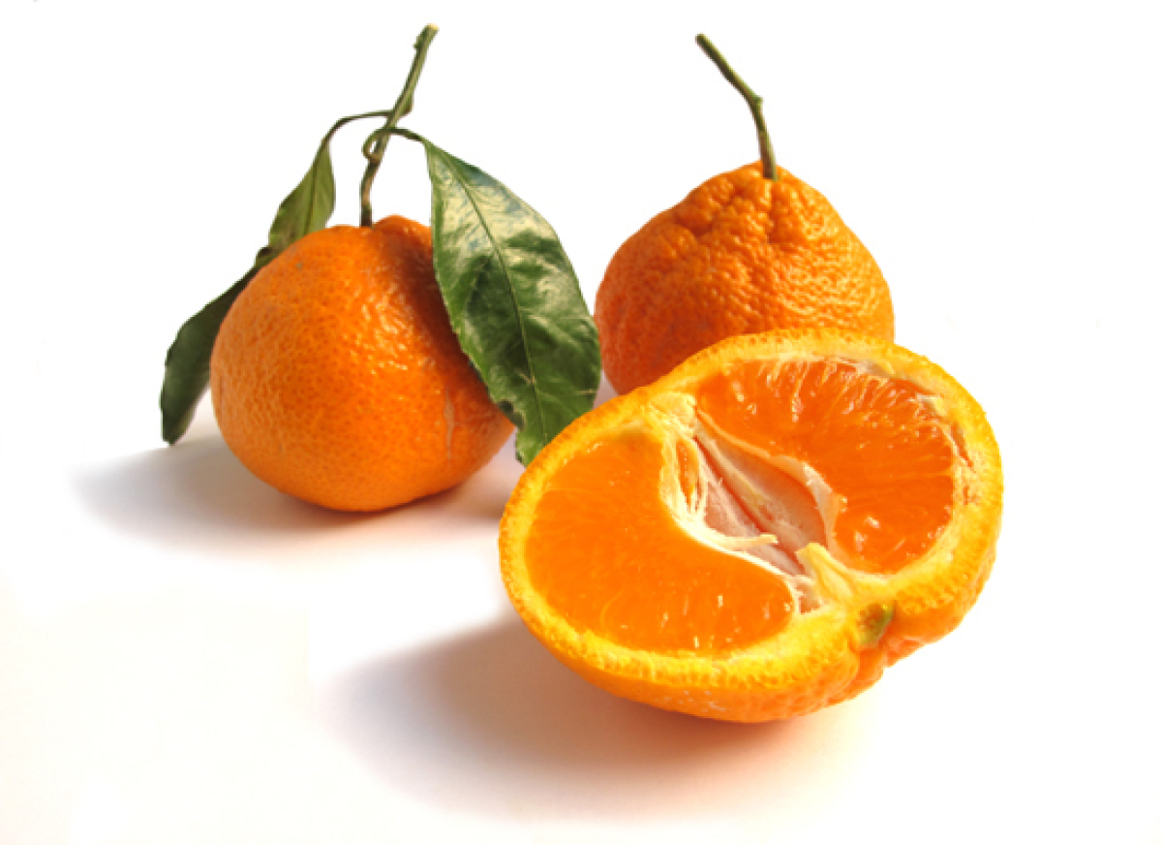

**Also Known As:** Seedless mandarin

**Available:** Best from October to December

**Appearance:** Smaller than ordinary oranges, Satsumas have thin, leathery skin that is bubbled with oil glands. It should be noted that they're very delicate and easily bruise upon handling.

**Qualities:** Seedless and easy to peel, Satsumas are very sweet (they're known as "honey citrus" in China) with a tender, melt-in-your-mouth texture. They're great for eating out of hand.

**Origin:** Japan

**Our Tasters' Comments:** "Supremely plump and juicy. It's like a little pillow of juice in my mouth." "Complex, unique flavor." "Extremely delicate, juicy and sweet." "So juicy, but it has a strange aftertaste." "Interesting almost-berry flavor."

Cara Cara: This orange, a cross between two different types of navels, is one of our editors' favorites.

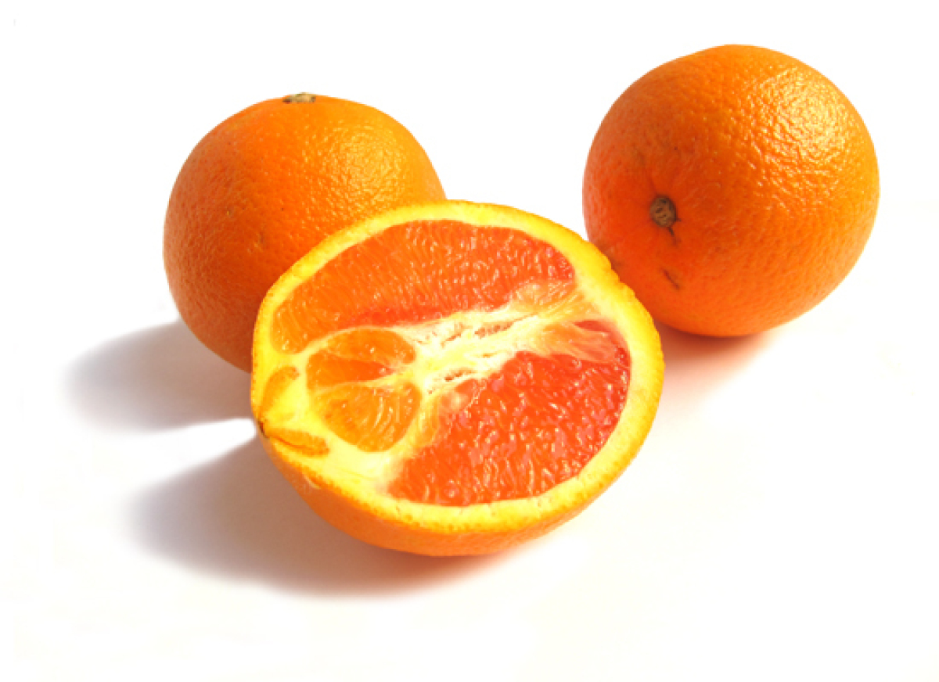

**Also Known As:** Cara cara navel, red navel orange, pink navel orange

**Available:** Best from October to December

**Appearance:** Medium sized with dark orange-pink skin

**Qualities:** Sweet and low in acid with a complex flavor and notes of berries

**Origin:** Venezuela

**Our Tasters' Comments:** "Beautiful color, great robust orange flavor." "Complex, floral flavor. Like a sweeter grapefruit." "Perfect balance between sweet and tart. A bit more like a grapefruit than an orange." "The tartness tastes a bit like strawberries."

Blood Orange:Blood oranges get their color from anthocyanins, pigments that are common in many flowers and fruits (but not often found in citrus fruits).

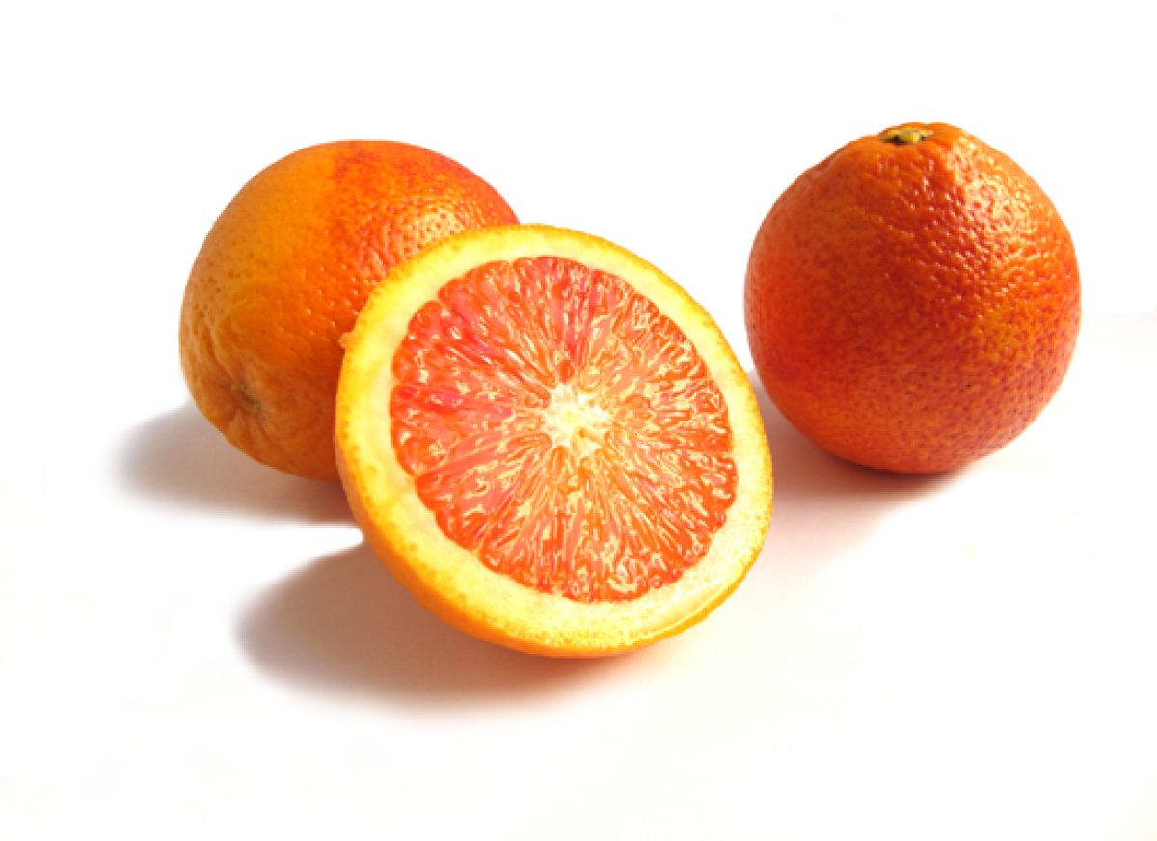

**Available:** December to March

**Appearance:** Orange exterior that's often stained with blood-red flecks (sometimes staining the entire exterior of the skin) with a deep red flesh. They're often smaller than the average orange.

**Qualities:** Blood oranges have a tough skin that's quite difficult to peel, and their taste is tart-sweet (the tartest of all oranges).

**Origin:** Italy, Spain

**Our Tasters' Comments:** "Sour! But in a delicious way." "Tastes like tart blackberries." "Wonderfully tart, great color." "Sour, juicy and beautiful." "The best! Great flavor and sourness."

Tangelo: The tangelo is a hybrid of a tangerine and either a pomelo or a grapefruit.

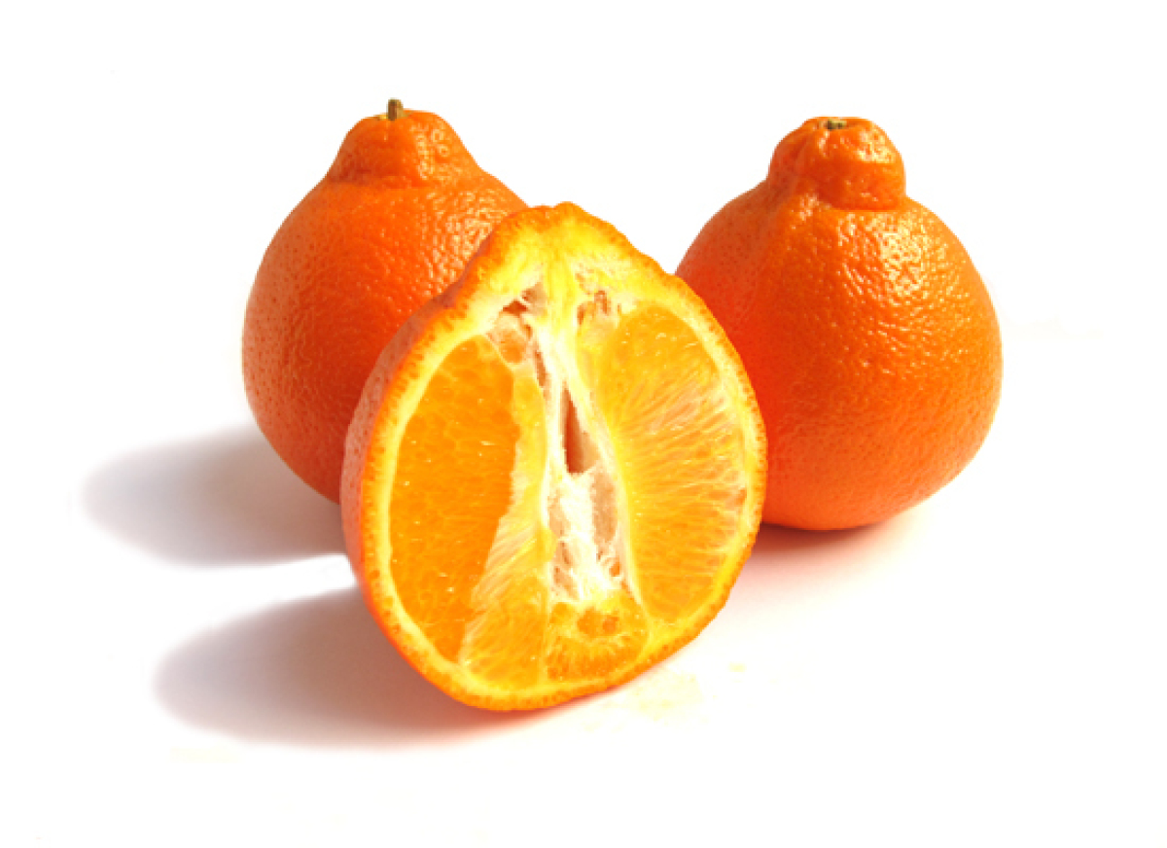

**Also Known As:** Minneola, Honeybell

**Available:** December to February

**Appearance:** Approximately the size of a fist, with a distinctive raised knob at one end

**Qualities:** Tangerine-type flavor, and extremely juicy with minimal flesh and loose skin, making it easy to peel. Tangelos have a balanced sweet-tart flavor.

**Origin:** Florida

**Our Tasters' Comments:** "Super juicy, but not as sweet as I'd like." "Almost pear or peach flavored." "Really, really juicy but lacking in flavor."

Navel Orange: Navel oranges are characterized by the growth of a second fruit at the apex, which protrudes slightly and resembles a human navel.

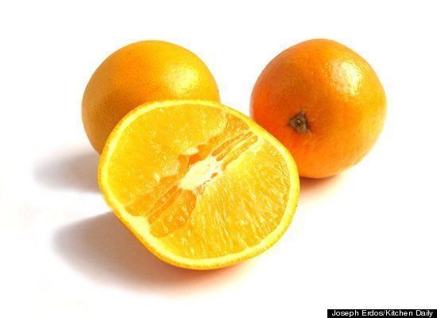

**Available:** November to April

**Appearance:** Navels are fist-sized and orange with that distinctive "belly button" at one end.

**Qualities:** The skin is thick and easy to peel, but the flesh is less juicy than other oranges. They're slightly acidic and are good eaten out of hand.

**Origin:** Brazil or Portugal (it's disputed)

**Our Tasters' Comments:** "Solid basic orange flavor." "Neutral flavor, firm texture." "A pretty tasty orange, though a tad on the tart side." "Nicely balanced flavor."

Juice Oranges:Valencia is the top orange juiced for making orange juice -- but these oranges aren't so enjoyable eaten out of hand.

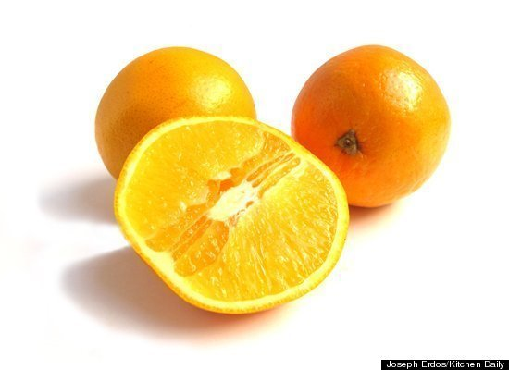

**Types:** Valencia, Hamlin

**Available:** March to June (late-season)

**Appearance:** Round and pale orange, with that classic orange look

**Qualities:** Sweet and juicy with seeds, but with an undesirable texture for eating out of hand

**Origin:** Valencia hails from California, whereas Hamlin was developed in Florida.

**Our Tasters' Comments:** "Dry and stringy -- that must be the reason these are used for juice." "The flavor is good, but it's too dry." "Strangely dry and juicy at the same time." "Fibrous." "Not good eaten out of hand."