**HOW TO CUT MANDARIN ORANGE IN A STRIP**:

[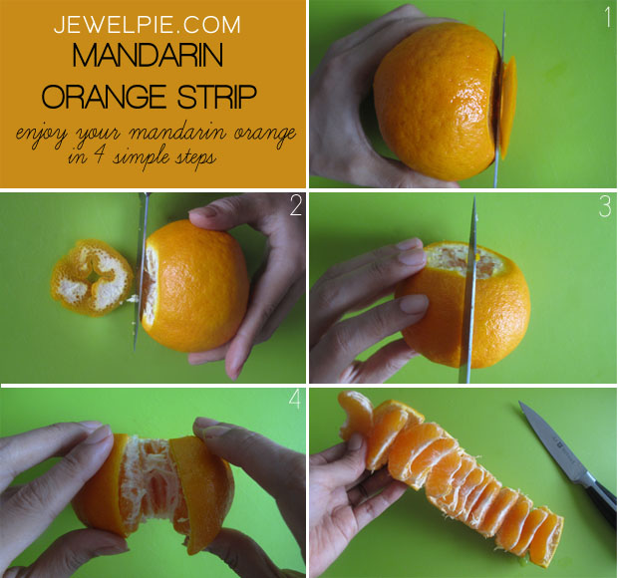](http://jewelpie.com/wp-content/uploads/2013/02/infographic-mandarinorangestrip.jpg)

Cut both sides of the mandarin orange (1, 2). Remember not to cut too much into it to avoid cutting the flesh. Cut a slit (3) and gently roll the orange out in a strip (4).