**West Coast Weather**

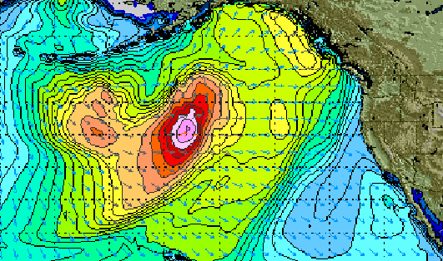

Monday wave model from stormsurf.com

**Season Openers & Holidays**

January 1st – New Year’s Day

January 1st – Alaskan Cod Fixed Gear

– Dungeness Crab

January 21st – Martin Luther King Jr. Day

**Bottom Fish**

Alaska: Cod is King right now as January 1st the Fixed Gear (Hook & Line) Cod fishermen of Kodiak will be fishing, baring the freezing spray and blizzard conditions. Trawl season starts middle of the month and between the two fisheries, we’ll be in fresh Pacific Cod from now through April.

Canada: Rockfish / Pacific Snapper is where it’s at… Mild flavor, Wild abundance, and focused fisheries. Good quota position on Rockfish for fresh fish ads as well as reasonable supplies of Fresh Frozen IQF fillets for value opportunities when the weather gets tight.

Lower 48: Petrale and Dover Sole is the combo we’ll be seeing for January. Fishermen get their new annual IVQ (Individual Vessel Quota) starting January 1st, so expect boats to target the money fish in the New Year to pay off some of those Christmas Credit Cards.

**Wild Salmon**

Preliminary run projections for sockeye salmon are beginning to trickle in from Alaska and although the overall outlook is for a down year, there may be some areas that will provide opportunity for the fresh market, such as Upper Cook Inlet, which is projected to have a strong return.

King Salmon will also be facing supply challenges in Alaska as several catch areas may not even have a directed commercial fishery. A few of these areas are the Stikine and Taku River in SE Alaska and Upper Cook Inlet

Kings – Fresh king salmon will be scarce through the winter months due to weather hampering the only fishery in effect = Alaska’s winter troll king fishery. This quota fishery typically peaks in late March or early April with landings sporadic until then. Although fresh kings will be difficult to find, excellent frozen options are available: Frozen H&G Klamath River Kings, FAS (Frozen At Sea) Troll Kings, and Vac Pac PBO King Fillets offer great options. Ask your local sales rep for assistance guiding you to the best option.

Sockeyes – Our next fresh opportunity on Sockeyes kicks off with the infamous Copper River opener usually in mid-May. As with Kings, great frozen options are available. Whole H&G, Vac Pac PBO Fillets and Vac Pac portion sized offering are available.

Cohos – We continue to see a few late season Cohos coming from Puget Sound, Klickatat River (Upper Columbia River), and Wilapa Bay. Prices are high due to supply and demand, but these do offer a nice late season fresh wild option. Frozen options are limited on Coho as Alaska had another disappointing season with most of the catch going to the fresh market. Some frozen Vac Pac sides are available upon request.

Ketas – Nice quality fresh Ketas or Chums continue to be harvested from Puget Sound. This fishery is winding down however, and quality will lessen as many of the fish will turn dark and their flesh will begin to pale out. Plenty of frozen options are available with one of the more desirable options being the fabled Yukon River Vac Pac Keta Fillet.

Pinks – Fresh season will begin in PWS (Prince William Sound) in June. Frozen H&G and fillets are also available

**Atlantic Salmon**

The market is mixed with origin having a big impact on cost. The gap between Canadian fish and Chilean fish has widened making Chile a much better value. This gap is expected to narrow in the coming months as Chile begins to firm up. Chileans are finding some better markets for their fish in other parts of the world thus bolstering their demand and causing a firming tone. Despite all of this, Atlantic salmon is currently a tremendous value for you to promote and utilize as many ways you as you can. This will be the case throughout 2013.

**Steelhead**

Production on NW Steelhead is ramping up at our farm in Okanagan, WA. Now would be a great time to promote the fish. The pricing will remain steady on the product for the foreseeable future, ensuring the great value of the fish.

**Dungeness Crab**

With all the season delays, most frozen crab stocks have been wiped out. The good news is that fishermen and processors have finally agreed to a price and will go fishing on Dec 31 (weather permitting) off the Oregon and Southern Washington coasts. Fresh crab should be available a few days after that. Once the crabbers are fishing, we expect the price to moderate from what we have seen the last week or two.

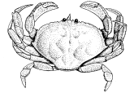

**Halibut**

Frozen inventories continue to move out. There are still plenty of U/20 H&G fish available along with 1/3 lb Fletch. The 2013 season is expected to open mid-March as usual and the quota this year will be cut back another 25%. As a result, we expect prices for new season fish to be strong.

**Snow Crab**

Alaska Snow Crab season will kick into full gear mid-January. Although the quota is down this year, the expectation is for good supply and the market is ready for it. Inventories of larger sizes remain scant. 5/8’s are still readily available in both Canadian and Russian packs.

**King Crab**

Market prices for finished packs of all sizes, Red and Gold, have adjusted down and have found new levels for 2012/2013 sales. With these adjustments we have seen increased sales on all sizes of crab through the holiday period. Supplies of all sizes, except the largest 4/8 and 6/9’s, are in good supply.

Russian Bering Sea crab season is wrapped up and last shipments are coming to market. Expect smaller sizes to stay stable in the coming months, as next round of fishing will not begin until late winter or early spring for both Blue and Gold King Crab.

**Shrimpmeat**

Hard to believe, but the west coast shrimp season is just 3 months away from starting!  In the meantime, Cooked and Peeled Shrimp are still the best deal going as a cooked ready to eat item. This sweet, tasty shrimp already cooked and ready to eat, continues to grow its market share across our country as newcomers taste and come back for more. We are packing and filling firm orders now. Please let us know what you need.

**Chilean Sea Bass**

The fishing for sustainable Patagonian Toothfish is a year round fishery. The MSC fishery is open from MAY-AUGUST for the area around South Georgian Island. However all harvests of Sustainable Patagonian Toothfish are at a low point of the season and this will probably continue through the next 4-5 months. There are currently some gaps of containers of Patagonian, but there is product in the pipeline. There may continue to be small increases in costing with Patagonian, especially with smaller sizes of 6-10KG, as this size is the choice of Asia and Japan. Harvests of Mawzoni from the Ross Sea has begun but it may be March before new harvests from this year hit the market here in the US. When the Mawzoni enters the marketplace it may steady markets and prevent any further increases.

Value added Chile Sea Bass items such as portions and fillets are holding firm in market costs and there is no increase foreseen in the near future.

**In Shell Oysters**

Shucked oyster supply availability should be good and quality is great. The meat tends to be firmer and no spawning.

⮚ Kumiai Oyster

⮚ Fanny Bay Petite – Vancouver Is.

⮚ Fanny Bay X-Small - Vancouver Is.

⮚ Windy Points X - Small-Samish Bay

⮚ Pacific Oyster 3-4” - Hood Canal, WA

⮚Totten Inlet X-Small – Totten Inlet

⮚ Kumomoto - Humbolt Bay, CA

⮚ Penn Cove Select - Samish Bay, WA

⮚ Kusshi-Stellar Bay - B.C. Canada

⮚ BBQ’s – 4-8” – Hood Canal, WA

⮚ Baynes Sound 2-3” – B.C. Canada

⮚ Dabob Bay – Hood Canal, WA

⮚ Pacific 2-3” Clean - Hood Canal, WA

⮚ Shigoku Petite –Willapa Bay, WA

⮚ Pressure Shucked-Willapa Bay, WA



**Mussels**

We currently have 3 varieties of mussels:

***Penn Cove Mussels*** - Plenty of product, readily available, these have the majority of the beard removed.

***Taylor Mediterranean Mussels -***

Meat fill has been excellent. Both medium and large sizes available.

***Whales Cove Mediterranean* -**

Our favorite mussels from Mexico. A little larger than local mussels but they are an excellent morsel of meat.



**Squid**

Squid fishing is closed until April; hopefully there will be good landings when fishing opens again.

Export has slowed down a bit for the winter months, and China wants to wait until new season production starts.

Cleaned squid and frozen whole domestic squid availability is good with steady sales; however a slight flux is anticipated in upcoming cleaned squid production. This is due to a lot of smaller sized squid from the end of last season. Consequently squid sizes will affect the cleaned squid production. Larger sized squid are preferred for cleaning, so product allocated for cleaning stock has already been shipped and processed from this last season raw materials.

Expect smaller size squid offered at somewhat cheaper levels and beware of quality in the upcoming months from competitors.

**Scallops**

The New England Fishery Management Council adopted Framework 24 in November 2012, setting the quota for the scallop fishery for 2013. Although we do not yet have the definitive quota by area, we know that there will be two significant changes in 2013. One: the Closed Area trips will be reduced from the traditional 4 or 5 trips to only 2 Closed Area trips. Two: each trip will only be 13,000 lbs as opposed to the traditional 18,000 lbs permitted since the plan was put in place. US Landings are expected to decline by approximately 30% in 2013. We do expect landings to normalize again by 2015. NOAA tracks landings by calendar year, although the season starts on March 1st and vessels can carry forward up to 10 days at sea. Therefore there could be a transfer of weight once the 2012 actual figures are released in February.

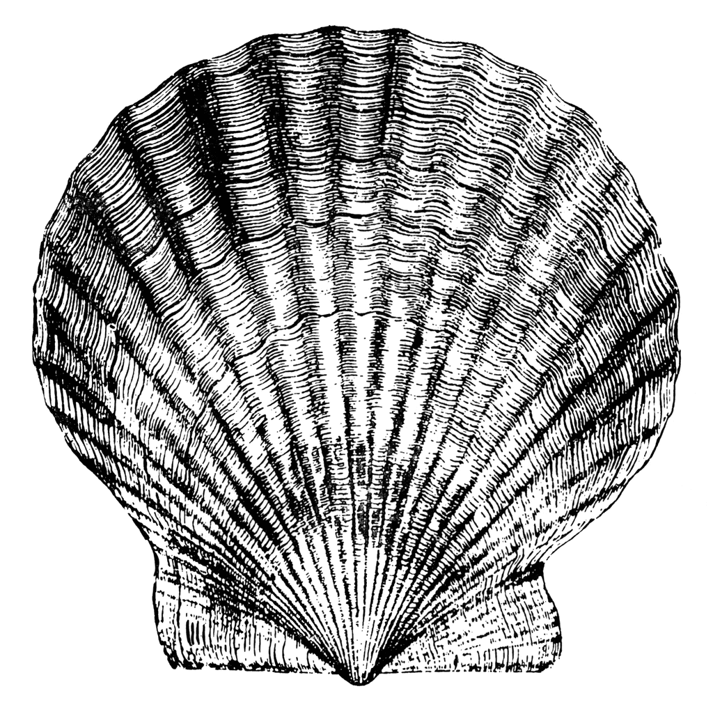

**Prawns**

Early Mortality Syndrome (EMS) is hitting many shrimp farms this year. Prices continue to firm. We are not expecting to see price decreases from overseas suppliers until end of March.

**Domestic Catfish**

It appears that the Catfish industry as a whole will process about 12% less fish in 2012 than 2011. This is mainly due to a decrease in market share caused by high prices in 2011. Fresh sales have actually increased as 2012 has progressed, but frozen sales have been slow. Supply looks to be steady for the next several months including the Lenten period. Pond Bank prices are expected to rise in the first quarter because of an increase in feed prices, and because farmers are actually losing money at current pond bank prices. We expect about a 10-15% increase in pond bank prices during the first part of the year.

**Tilapia**

Fillet sizes ranging in 2-5 oz are being packed for customers for the Lent Holiday keeping pressure on pricing and limiting raw material availability. Prices will continue to increase through March. The plants are still very busy packing for large shipments before the Chinese New Year.

**Swai**

Month to month supply of Swai continues to be steady and the market reflects this. This fast growing farm raised fish is an excellent value. There are wide variations in product that impact the quality of the product, so buyer beware. One of the best features of swai is that it is available in a wide variety of fillet sizes at virtually the same price, making it versatile to a number of applications.

**North Atlantic Lobster**

The major holiday demand is now behind us. Despite this seasonal strong demand, the overall market remains stable on smaller sized tails. Large tails are a challenge. The next major harvest is in May of 2013, so there are no new harvests of large tails until then. North Atlantic lobster remains an outstanding value in the lobster category.

**Beef**

Boxed beef cutout values lower on Choice and firm on Select on light to moderate demand and offerings. With kill levels reduced this week, packers had an easier time keeping the majority of prices propped up. End meats in particular saw firmer prices as demand for those cuts remained strong. Fed cattle grinds similarly traded at firmer prices. The rib primal, on the other hand, took a heavy hit this session, especially on Choice, as buyers no longer feel the need to pay a premium for high quality middle meats. Beef trimmings began moving lower by midweek as packers struggled with the fact that most major grinding operations will be shutting down for three straight days due to Christmas falling on a Tuesday. The only alternative was selling the product at a discount to buyers willing to box it up and freeze it. Forward negotiated sales were moderately active, with decent consignments of Choice inside rounds and ground beef, which sold in the higher range of spot market prices.

**Pork**

The pork cutout was weak late in the trading period with the decline in ham value. Mid-week most of the Midwest faced a severe winter storm that hampered movement and caused major logistical problems for much of the industry. Packers were able to hold retail cut items at generally steady prices throughout the week, on moderate demand for light to moderate offerings. With the diminishing demand noted last week on hams heavy offerings was noted, causing pressure on packers to lower prices to keep inventories in balance. The trimming complex saw reduced demand, as processors had their needs met for delivery into the short holiday week. Lean trimmings were stagnant this week as food service continues to absorb excess loads.

**Poultry**

Preliminary majority prices are higher in the East and Midwest, but unchanged in the West when compared to early week. Whole broiler prices are firm to higher in the East and Midwest, and steady in the West. Offerings of all sizes are seasonally light. Demand into all channels cover the full range, but is mostly moderate entering the weekend. Due to the upcoming holiday, truck shortages are still being reported for deliveries and processing schedules will be mostly part time for the next two weeks. Floor stocks are balanced. Market activity is moderate to active. In the parts structure, movement is light to moderate. Prices are trending firm for wings and bone-in breasts, and holding steady for the remaining items. Supplies of wings and bone-in breasts are light to moderate, and all other parts are available. Market activity is slow to moderate. In production areas, live supplies are moderate at desirable to heavy weights.



**Pacific Seafood Company**

Mukilteo 425-347-7994

Tacoma 253-627-2158

Spokane 509-928-9076

Clackamas 503-905-4500

Sacramento 916-419-5500

Fresno 559-264-3474

Las Vegas 702-566-8670

Salt Lake 801-908-8292

Phoenix 602-268-3313

San Antonio 210-226-4343

Houston 713-694-4242

Los Angeles 310-835-4343

**Check out:**

[**www.pacseafood.com**](http://www.pacseafood.com)

