Inflation Will Never Go Up Again

By Paul Price

Really? My health insurance premiums have skyrocketed. My kids’ pre-college and university tuitions have been ramping up. The cost of filling my gas tank has soared. Shiny new menus at restaurants mean higher prices - cash-strapped operators do not print them just to offer exciting new entrees.

Obamacare's implementation will make matters worse. Franchisees won't be able to absorb the added cost of healthcare coverage, or the $2,000 per worker penalty. This expense will be passed along as higher prices.

Despite these anecdotal experiences and predictions, the government’s Bureau of Labor Statistics (BLS) tells us each month that the Consumer Price Index (CPI) is barely above neutral year-over- year. It all comes down to how ‘inflation’ gets defined.

People generally think of annual inflation as the cost of a basket of goods and services today versus the cost of the identical basket one year earlier. While that makes sense, it is NOT what the BLS measures and reports.

If you want the details of the BLS report, read the fine print (below). The CPI-U is said to represent the index for all urban consumers.

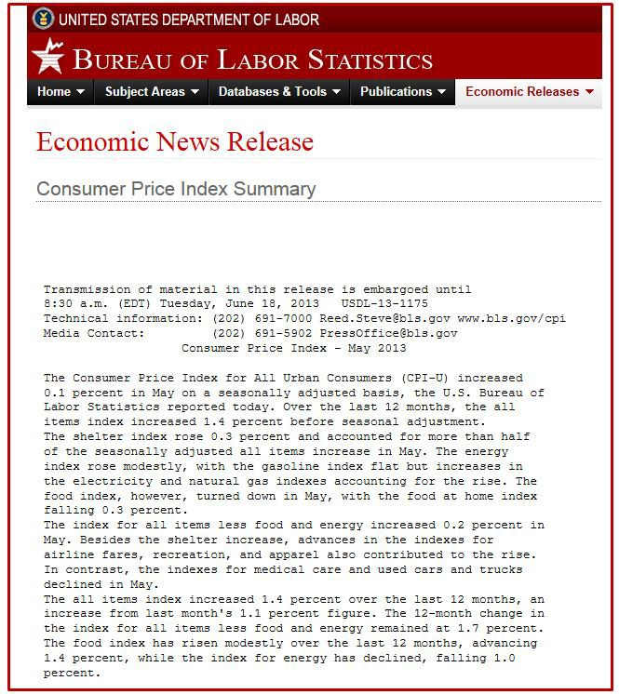

Core CPI specifically excludes food and energy costs, reflecting reality only for people who don't move, eat or buy any products requiring transportation.

Rapidly rising income, property and sales taxes are not included in any of the BLS inflation numbers. Taxes add to the cost of living.

I traveled to Iceland last September. Part of that country’s post-2008 crisis management was the imposition of a 25.5% VAT (value added tax) on almost every retail purchase. Paying 25.5% in sales tax means each Krona can buy only 74.5% of the currency’s face value in real merchandise or services. Money unspent does not go towards paying VAT. But never spending money is the same as not having it.

Iceland imposed currency controls due to its banking industry failure. Citizens cannot move their wealth outside of the country; they cannot buy non-Kronur denominated securities without prior government approval. In practice, Icelanders will either pay the prohibitive 25.5% tax or forfeit spending their already-taxed earnings.

The same plan, with slightly lower rates, is in effect all over the Eurozone. When VAT rates move higher, inflation - defined as the cost of living - increases. (Imposing a national sales tax in the U.S. is a terrible idea. Taking money away from those who need it or could use it productively, and giving it to government, will allow politicians to do more damage. Deficits and spending won't drop.)

As an aside, ‘temporary’ taxes are rarely temporary. The June 29, 2013, Philadelphia Inquirer recounted the story of the Johnstown Flood Relief tax of 1936. A 10% surcharge on all alcoholic products was levied to help the townspeople. 76 years later the tax has risen to 18% and is built into all Pennsylvania liquor sales. None of it is earmarked for Johnstown. The hidden tax is part of the final retail price that then becomes subject to PA’s state level 6% sales tax. After compounding both taxes, the final cost is 19.08% at the register. The price of booze is not included in official inflation lists even though government policies may be driving us to drink.

Excluding food, energy and taxes from core CPI allows the BLS to understate increases in the true cost of living. After high inflation years in the late 1970s, the government changed how it calculated CPI. This happened again in 1990. Each time, the BLS manipulated the measurement techniques to downplay the extent of cost increases. This lessened the government’s need to increase Cost of Living Adjustment (COLA) applied to employees and retirees.

The excellent ShadowStats website provides monthly updates on what CPI would read if the rules were still the 1980 rules. The difference is startling.

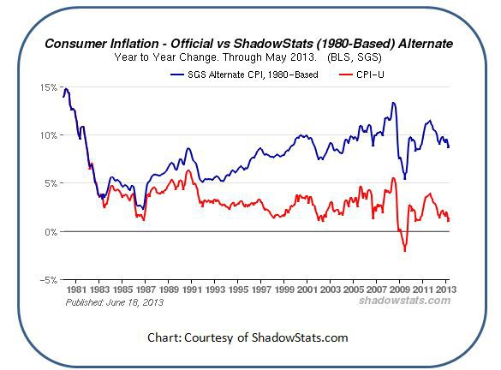

Some BLS tricks are even more devious.

The BLS uses other tricks to lower reported inflation rates. The ‘substitution principle’ says that when the price of a particular item, e.g. rib-eye steak, rises, consumers will switch to lower-priced alternatives like ground beef. Under that scenario a 20% rise in rib-eye steak prices disappears

completely if it can be offset with ground beef costing 20% less. If Lexus or Porsche MSRP’s go up 30%, it doesn't matter because the consumer can buy a Kia or Hyundai instead. No inflation adjustment required.

Our leaders also call improvements in quality with unchanged pricing ‘deflationary’. The first iPads were crude by today’s standards but cost $600. The newest iPad with Retina Display still costs $600 but packs more power and features. The BLS counts that as a drop in price even though the price is the same.

Until consumers are walking to work and eating cat food, the substitution principle allows the BLS to call CPI anything it wants.

A real-world consumer poll showed very large increases in the out-of-pocket cost of living over the period from Q1 2001 through Q1 2013. The official change in CPI is almost invisible over that same period.

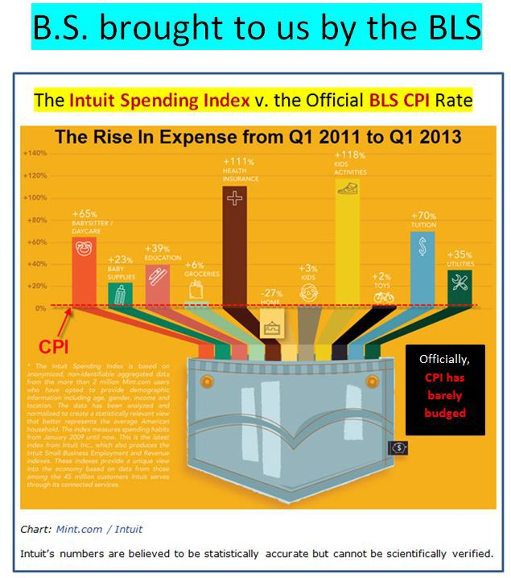

Anyone who pays their electric, tuition or grocery bills, or funds their own health insurance plan, is painfully aware that the CPI and CPI-U numbers do not reflect reality.

The cost of living has been rising at a fast pace. Inflation, as measured by the CPI, will never go up significantly unless politicians abandon their deceptive practices. Unfortunately, Washington D.C. has a strong interest in keeping the public uninformed.

Read the latest Market Shadows Newsletter, Fables and Fairy Tales (7-3-13).

