**Name The New Reserve Currency: China Imports More Gold In 2012 Than All ECB Holdings**

The last time [we looked](http://www.zerohedge.com/news/hoarding-continues-china-has-imported-more-gold-six-months-portugals-entire-gold-reserves) at monthly Chinese imports of gold from Hong Kong in 2012, the comparable country in question was Portugal (whose citizens, if not central bank, incidentally have [run out of gold to sell](http://www.zerohedge.com/news/portuguese-run-out-gold-sell)), because that is whose total gold holdings (at 382.5 tons) Chinese imports had just surpassed. Fast forward a month later, and the update is even more disturbing. In July, Chinese gold imports from HK, after two months of declines, have picked up once more and hit a 3-month high of 75.8 tons. While it is notable that this number is double the 38.1 tons imported a year prior, and that year-to-date imports are now a record 458.6 tons, well over four times greater than the seven month total in 2011 which was 103.9 tons, what is far more important is that in the first seven months of 2012 alone China has imported nearly as much gold as the total holdings of the hedge fund at the heart of the Eurozone, elsewhere known simply as the European Central Bank, and just as importantly considering the import run-rate has hardly slowed down in August, which data we will have in a few weeks, **it is now safe to say that in 2012 alone China has imported more gold than the ECB's entire official 502.1 tons of holdings.**

[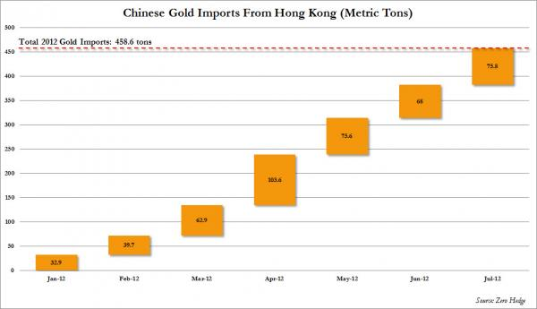](http://www.zerohedge.com/sites/default/files/images/user5/imageroot/2012/08-2/China%20Imports%20July.jpg)

What is most amusing is that China, via the IMF, still wants the world to believe that total Chinese official holdings are just 1040 tons (double the ECB's), when it has imported half this amount in 2012 alone.

[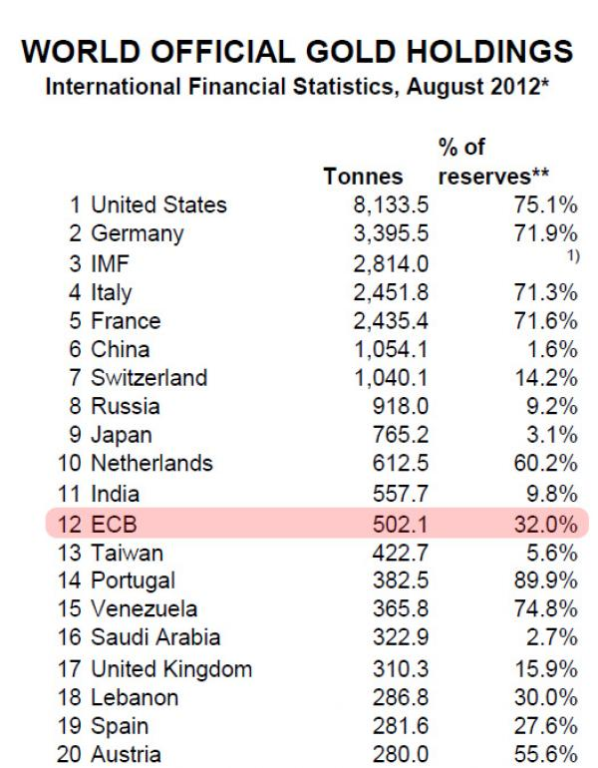](http://www.zerohedge.com/sites/default/files/images/user5/imageroot/2012/08-2/WGC%20Holdings.jpg)

As a reminder, the last time China gave an update of its *official* gold holdings [was in April for 2009](http://news.bbc.co.uk/2/hi/business/8020721.stm). This means China has been aggressively hoarding gold for the past three and a half years without issuing an official peep about where its inventory stands now.

Luckily, those who keep track of the newsflow have some idea.

As an even more important reminder, [in December 2009](http://goldnews.bullionvault.com/china_gold_10000_120120092), the China Youth Daily quoted State Council advisor Ji as saying that a team of experts from Beijing and Shanghai have set up a "task force" last year to consider growing China's gold reserves. "**We suggested that China's gold reserves should reach 6,000 tons in the next 3-5 years and perhaps 10,000 tons in 8-10 years**," the paper quoted him. Has China managed to accumulated 6,000 tons yet? We won't know for sure until the official disclosure which will come when China is ready and not a moment earlier, but at the current run-rate of accumulation which is just shy of 1,000 tons per year, it is certainly within the realm of possibilities that China is now the second largest holder of gold in the world, surpassing Germany's 3,395 tons and second only to the US.

Going back to the "important things", here is another one: in all of 2012, according to [Treasury International Capital flow data,](http://www.treasury.gov/resource-center/data-chart-center/tic/Documents/mfh.txt) China has increased its Treasury holdings from $1,151.9 billion as of December 31, 2011 to just $1164.3 billion: a total increase of just $12.4 billion in 6 months: the slowest run-rate since China started to recycle in budget surplus into US paper.

[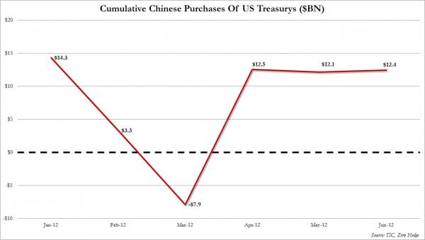](http://www.zerohedge.com/sites/default/files/images/user5/imageroot/2012/08-2/China%20TSY%20Purchases%202012.jpg)

Whether this dramatic slowdown (and no, China is no longer rerouting purchases via the UK whose holdings have, unlike prior years, hardly budged in 2012) is due to a plunge in the Chinese trade surplus due to the ever more obvious Chinese hard landing, and the lack of recyclable dollars, is unknown and largely irrelevant. What is known, and what is relevant, is that at Friday's closing price 458.6 tons of gold translates into over $25 billion worth of gold imports.

**For the first time in history China has imported twice as much gold as it has "imported" US Treasurys**.

But most importantly, and perhaps tying it all together, is what the deputy director of the Chinese central bank, the PBOC, said overnight at a conference in Xiamen. What he said is that the financial crisis has shaken confidence in the U.S. dollar. We knew that. What he added is that   
the sound performance of China’s economy during the crisis boosted demand for yuan. This was also more or less known, although with the Yuan peg it is somewhat difficult to determine objectively. It is what he said last that is most important: "**The financial crisis that started in 2008 has provided China with a good opportunity to promote the yuan as a global currency**."

A global currency that is now backed by the second largest hoard of gold in the world, and targeting to be over 10,000 tons in a few years, and is supported by the fastest growing "developing" economy in the world, $14 trillion in deposits rising at an exponential pace, and well over one billion in population.

Can anyone guess which currency is next in line of succession:

