**Topco’s Meat Outlook Report**

**April 26, 2012**

**The downturn in cattle supplies is widely telegraphed by now, but it has been exacerbated by the historic drought of 2011 in the Southern Plains.** At the first of the year, the U.S. beef cow herd stood 3.1% below a year earlier and down nearly 9% from its last cyclical peak in 2006. Much of the past year’s decline in the beef cow herd took place in Texas, where there simply was not enough grass (or hay) to sustain the cow herd through the winter. But before we get into too much detail on this subject, let’s summarize the basic story this way:

1. Cow/calf operations are clearly profitable…clearly, the most profitable of any segment in the entire beef supply chain;
2. The beef cow herd is probably expanding in the Northern Plains and in other parts of the country, where forage supplies are plentiful;
3. Apart from the lack of forage supplies in the Southern Plains, growth in the beef cow herd is being impeded by the competition for pasture land from high grain prices, and the difficulty that ranchers face in obtaining the necessary credit to expand their herds.

Calf prices have become high enough that the cyclical trend in beef cow numbers is probably stabilizing, and is soon to turn upward. As it occurs, both cow and heifer beef production will decline. We expect this trend to become evident in 2012—but in varying stages.

**The first stage will be in the reduction of cow slaughter.** If culling rates in the beef cow herd simply return to “stabilization” levels in the year ahead, then cow slaughter will be about 11% below a year earlier in the second quarter and down about 12% in the second half of the year. If ranchers shift into a “herd rebuilding” mode, then cow slaughter will be even lower.

The prospective tightness in cow beef supplies has obvious implications for ground beef prices, since cow beef comprises such a large component of lean grinding beef in this country. We estimate that in 2011, cow beef accounted for approximately 45% of the total U.S. supply of lean trimmings (counting everything 73% or higher as “lean”).

The recent withdrawal of a majority of supermarket and restaurant chains from the use of Lean Finely Textured Beef will compound the tightness in lean processing beef supplies. How can it not? This input can only be replaced with highly lean trimmings from cow beef, fed beef, or imported beef. Demand for all the above will increase, and materially so, as supplies decrease. We estimate that “LFTB” accounts for about 6% of the total supply of lean processing beef. In this equation, the market for lean trimmings is potentially explosive. Ground beef prices will increase, and we suspect that 4th quarter in particular will see many ground beef items achieve new record highs.

**The second stage of supply reduction will be reflected in a smaller number of heifers moving into feedlots,** which instead will be held back for breeding. We have not yet detected that this is happening, but eventually it will….and the microeconomics suggest that it will indeed happen, at least to some degree, this spring and summer, extend well beyond that point. As it does, the flow of heifers into feedlots will be restricted. This will bring about a material reduction in fed cattle slaughter, but probably not until the fourth quarter.

Despite the ongoing reduction in total feeder cattle supplies—they were down 1.4% last July and down 2.5% in January; and the feeder cattle supply *outside* feedlots was down 4.5% at the beginning of the year—placements have just now begun to drop off. From October through February, they were off less than 1% from a year earlier. How so? Well, the market has “bailed out” cattle feeders up to this point, rising enough to keep feeding margins generally profitable up to this point. With money in their collective pockets, cattle feeders have paid exorbitant prices for feeder cattle, outbidding other outlets for calves and yearlings. [The drought in the Southern Plains narrowed the capacity of those “other outlets” as well.] The market has reached more deeply into the pool of feeder cattle supplies up to this point in order to satisfy demand (demand for feeder cattle that is). This set of circumstances is about to change, however. Cattle that have been placed over the past six months or so will require cash prices of anywhere from $125 to $135 per cwt to break even; when these cattle are sold this spring and summer, it’s unlikely that the spot market will accommodate them. Cattle feeding losses will mount; as they do, placements will decline. This is an oft-repeated turn of events in the modern history of the feedlot business.

But in the meantime—i.e., over the next two to three months—the market will have a fairly comfortable supply of fed cattle with which to deal. Partly because of the steady rate of placements through the fall and through most of the winter, the inventory of cattle on feed 90 days or longer will remain above a year earlier until August 1, even with adequate marketing rates in between.

One other consideration is that steer carcass weights will be 15-20 pounds heavier than a year earlier through the spring, as they are now. If carcass weights follow a normal, seasonal path from this point forward, they will remain above a year earlier through the summer.

**And so in total, combining fed and non-fed (i.e., cow) slaughter along with likely carcass weights, we project the following picture of total beef production:**

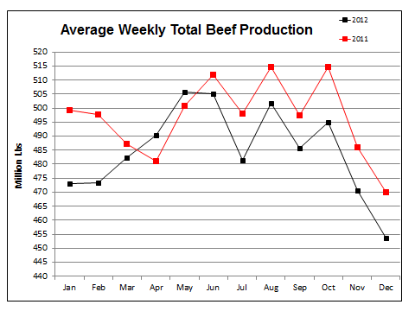

The salient point: total beef production will rise briefly above a year earlier in April and May, reaching a peak in that time frame; and then fall below a year earlier from that point as far out as we can reasonably discern. Production is only part of the story. A somewhat different—and more bullish—picture is painted when we consider foreign trade and demand.

**In regard to foreign trade, we are basically facing increases in both imports into, and exports from the U.S.,** for different reasons. Assuming that U.S. prices of lean processing beef rise as we expect, more beef will be attracted into the U.S., even as the Australian dollar remains near historical highs. As a reminder, one third to one half of all imported beef comes from Australia, New Zealand, and Uruguay combined, the vast majority of which consists of lean grinding beef. We expect that total imports of beef into the U.S. in the second quarter will average 232 million pounds per month, up 18% from a year earlier; and in the third quarter, 276 million pounds per month, up 7%. Depending on the extent of the increase in U.S. lean ground beef prices; these projections might be somewhat conservative. We should note that after several years of herd expansion, Australian cattle supplies are on the upswing.

The potential increase in prices of lean processing beef (both domestic and imported) has been heightened by the sudden rejection of Lean Finely-Textured Beef trimmings by a majority of retail and foodservice outlets. With LFTB being 94% lean and commonly comprising 10-15% of the ground beef blend, it can only be replaced with either domestic or imported lean grinding beef at a time of not only cyclically but also seasonally declining cow beef supplies. This story is far from over. The increase in importations of lean processing beef will serve as a buffer of sorts, but will probably not prevent the ground beef market from climbing upward from here.

**As for exports, the general trend remains upward but at a slowing pace.** In 2011 U.S. beef exports grew by a remarkable 21%; through the balance of 2012 we expect them to expand another 18%, mostly by virtue of an expected decision by Japan to relax the age restriction on beef imported from the U.S. and Canada to cattle up to 30 months of age from the current 20-month-old restriction. Our guess is that this change could take place sometime this summer, and thus would impact exports mostly in the final four to five months of 2012…..once again, coinciding with tightening cattle supplies.

**Meanwhile, domestic demand for beef at the wholesale level is trending upward, and we do not know of a good reason why this trend would not continue in the short term:**



In spite of higher retail prices, the seasonally adjusted domestic wholesale demand index reached an all-time high in March. For clarification, this index takes into account imports and exports by adding the former and subtracting the latter from the domestic beef supply.

It is perhaps an obscure line of reasoning, but the statistics confirm that as domestic beef supplies shrink, the market reaches more deeply into a more resilient, “core” level of demand which is less elastic in nature. Generally speaking, demand from the restaurant sector is far less responsive to changes in wholesale prices than the supermarket sector, simply because supermarket retail prices are adjusted much more frequently and flow of product through the “pipeline” is more variable. As long as menu prices remain constant, a restaurant chain will purchase a relatively constant amount of beef regardless of the wholesale cost. And so as more of the price-sensitive buyers are driven away, greater wholesale price increases are required to ration demand.

And so as domestic beef supplies continue to shrink—as they most surely will—inflation in wholesale beef prices will accelerate. This will be reflected in stronger demand at the wholesale level. It’s very hard to gauge the extent of the increase in demand that we will face during the remainder of this cyclical downturn in beef supplies, but the pattern described in the picture above would result in the sort of composite wholesale beef prices that are depicted in the chart on the next page. And within that scenario, live cattle prices would spend the balance of the year essentially bounded by $120 on the low side and $135 on the high side.

**As a final note on the major dynamics of the beef market, the outlook strongly suggests that the existing overcapacity in both feedlot and slaughter segments will intensify.** Inevitably, this will lead to shuttering of feedyards and at least one major slaughter plant. As measured by quoted spot market prices, packer margins have endured six months of extraordinarily negative returns, one of the longest stretches in recent history. We can only guess about when this will occur; but given that two of the four largest beef packers are publicly-traded companies, it is more than just a question of “who has the deepest pockets”…..just as has been the case in the chicken industry.

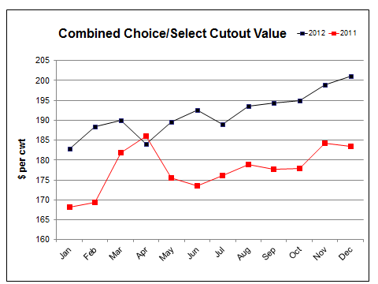

**Pork supplies are expanding at a cautious pace.** By all indications, that trend will continue in the foreseeable future. The U.S. breeding herd has increased modestly relative to a year earlier for five consecutive quarters and, as most recently measured on March 1, was up 0.6%. As of the same date, market hog inventories were up 2% from a year ago.

Beyond the simple fact that producers have made a decent margin over the past year-plus, the futures market has offered ample opportunity for them to lock in a positive margin throughout 2012. As more and more producers manage their risks, the prospect of increased pork production seems to be secured through the end of the year:

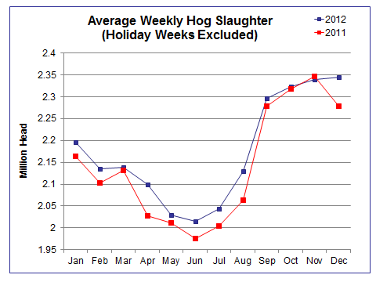

Increasingly, though, the domestic pork supply has less to do with domestic production and more to do with foreign trade. Last year the U.S. exported 23% of its pork production. This is a nice thing for the pork industry, but it is a two-edged sword; it also increases the dependence of the U.S. market on developments abroad. 2011 was a particularly dynamic year with respect to pork exports. At the beginning of 2011, Korea was beset with serious herd culling and a reduction in domestic pork production by a major outbreak of Foot and Mouth disease, necessitating a huge increase in importations of pork (much, but not all of which was supplied from the U.S.). This drove U.S. prices sharply upward in the first quarter. In the second half of the year, China purchased enormous quantities of U.S. pork in an effort to contain inflation in food prices. Neither of those conditions promises to repeat itself. The difference in wholesale pork prices between first quarter 2011 and first quarter 2012 is already evident; the difference between second half 2011 and second half 2012 prices is yet to be demonstrated, but it will be sizeable. Namely, in the absence of the capricious Chinese business, wholesale pork prices will be roughly 8% lower than a year earlier in the back half of 2012.

Perhaps the most efficient way to illustrate the impact of the “flattening”—we stop short of calling it “slowing”—foreign demand is to show the projected domestic pork supply (including imports and exports), which depict an increasingly generous supply as the year progresses:

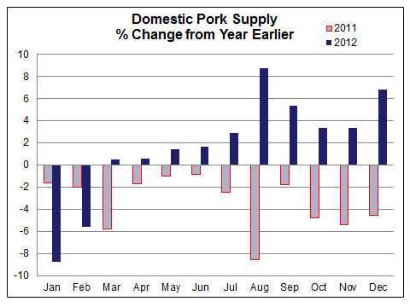

**Before we get ahead of ourselves, let us emphasize that U.S. pork exports remain quite healthy,** according to the latest readings. It’s just that this business enjoyed extraordinary growth in 2011 (+23%), a pace that will be difficult to match. We project a much more modest 4% growth in 2012, which assumes a marginal year-over-year *decline* over the next eight months. Perhaps it is this final point that is most relevant to the pork price outlook.

Over the past 12 months, the largest foreign customer for U.S. pork was Japan, followed by Mexico; China; Canada; Korea; Australia; and Russia. China, as we have already discussed, is likely to purchase substantially lower quantities through the balance of the year. Japan’s business is subject to some sort of slowdown as a result of a decline in value of the yen vs. the U.S. dollar, a trend that seems to be developing. Among other “solid citizens”, though, the prospects are promising. Demand from Mexico and Canada will be enhanced by lower prices relative to a year earlier, and demand from Russia will be aided by high prices of crude oil. The Australian dollar remains strong, and demand from Korea appears to have stabilized at a higher level.

In regard to domestic demand, the same basic principles affecting beef demand are at work in the pork market as well—only in reverse. With domestic supplies expanding, the market is now relying more heavily on the more elastic component—i.e., the retail sector—to prop up prices. Lower consumer-level prices of bacon, hams, hot dogs, etc. are needed in order to generate accelerated product movement. The market has been working to make this happen since about the middle of February, and has come a long way in doing so. In the meantime, the seasonally adjusted, domestic wholesale pork demand index has fallen well below a year earlier. Facing the prospect of much higher beef prices, we suspect that it will rise modestly from its current reading:

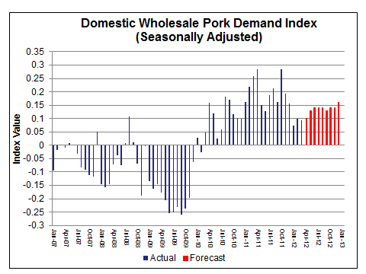

The combination supply and demand projections, then, allow for average wholesale pork prices that increase seasonally during the second quarter, but flatten out through the summer—as opposed to last year’s late summer and fall increase:

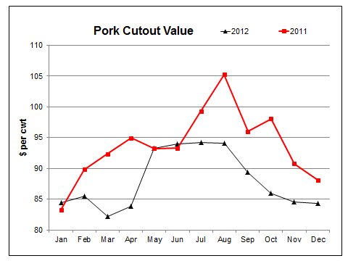

**Rarely has there been such a bullish “alignment of the stars” as exists in the chicken market.** Production has been cut back rather severely; freezer stocks have been drawn down; and wholesale chicken prices are cheap in relation to all competing proteins, just as we enter the season of typically strongest demand and greatest weather-related risk. All of these factors insinuate that chicken prices, boneless-skinless chicken breast prices in particular, are poised to launch, right? A major factor missing here is the fact that consumer demand for b/s chicken breasts is simply not, and hasn’t over the last couple years, increased by the expected degree. Consumer’s, and we can only speculate on the reasoning, have increasingly turned their attention towards darker meats. In particular, b/s thighs are a direct substitute in many cases, and price ratios to b/s breast meat have noticeably trended higher in recent years, especially given the increase in chicken sausage sales. Thus, while we suspect breast meat prices will go up for the grilling season, we suspect that those expecting a massive turnaround are going to be disappointed.

It is widely known that the major chicken processors have suffered considerably less-than-favorable results over the past year (or longer), and the publicly-traded companies among them have had a hard time prescribing to shareholders how they are going to “right the ship”. The natural response has been to cut production, and some cases, to consolidate production capacity. The net result has been a distinct and consistent reduction in egg sets/poult placements, on the order of 5-7%, that has persisted since last summer:

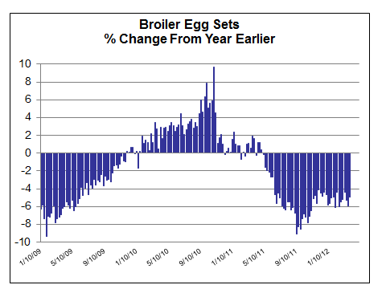

Year-to-date cutbacks in egg sets and placements equates to approximately 7 million less birds available each week. After accounting for ever-heavier average bird weights, actual chicken production (in terms of total pounds) has been running about 4.5% below a year earlier so far in 2012.

It is no secret that demand for, and prices of chicken breast meat typically strengthen at this time of year. On average over the past 15 years, chicken breast prices have increased by 7% from March to May and by more than 9% from March to August. Given the supply factors discussed above, it would be logical to suggest that prices would increase to a more substantial degree. However, we doubt that reduced consumer demand is going to return overnight, and suspect that prices would do well to simply repeat the average performance over the next couple months. While we are bullish for chicken prices as a whole, we suspect it will be the darker meats (and wings for that matter) that will perform exceptionally well. We had a comparable reduction in egg sets during 2009 and wholesale breast meat prices increased 40% at their summer high in July/August 2010. Given a similar price response in 2012, breast prices could measure into the mid-$1.70’s during summer peak.

Wing prices jumped to new record highs in January and advanced further to $1.88/lb in March, and subsequent seasonal declines have been minimal up to this point. You would be hard pressed to find an item that has benefited more from reduced broiler slaughter than chicken wings. After all, while birds have been bred for increased breast meat over the years, they still have only two wings. Supply reductions have certainly been a major factor in strong running prices through Q1 of 2012. However, demand has jumped significantly as well. It is important to remember that wing prices were exceptionally weak in 2011. Thus, in response, many food service institutions planned wing featured promotions in 2012. This will keep demand artificially high over the short term despite the record high prices currently characterizing the market. As we progress into the 2nd half of the year, we suspect promotional activity will be reduced and prices will fall as replacement costs will be significantly higher in most cases. The market experienced the same phenomenon in 2010, but wholesale wing prices corrected much quicker – 15% within two months and 35% within 6 months. High prices have carried through the first quarter and only recently starting to show some weakness, but this year’s wing correction is not likely to be a repeat of two years ago in large part because the industry has maintained control of production. That being said, a reasonable downside target this year is in the 25%-30% range which is likely to come later than seasonal norm of June/July.

**An early season buying rush and tight supplies have pushed frozen whole turkeys to record highs for each month of 2012.**  The turkey industry continues to have success in passing along higher production costs. After new record highs in November and softening feed costs during the fourth quarter, one would have expected a greater seasonal decrease from the fall high. However, strong demand in January restricted further price erosion. Given high prices to start the year and seasonal price appreciation, turkeys are likely to reach new record highs this November.

Feed prices have strengthened throughout the first quarter leaving growers to put more emphasis on marginal returns per bird. A grower’s optimal size range is between 14 to 16 pounds. As a result, the supply of larger toms, those greater than 24 pounds, has declined in recent years creating a premium the larger birds – higher prices to ration demand. There were only limited time periods prior to 2010 when such a premium existed. Year-to-date 2012, toms have averaged 8.6 cents per pound greater than smaller hens. Based on limited history, we expect this premium will remain in the 5 to 7 cents range through July and likely decline to the 3 cent level by November. Small hens are also cost prohibitive to the grower and despite this fact, small hens are not trading at a premium.

Given the recent surge in corn and meal prices, we do not foresee any significant downside risk in the months ahead from the feed cost side of the equation. Early season demand may cause price increases to moderate or level out during the late summer months. Third quarter pricing will be impacted by actual whole bird supplies. Turkey poult placements were nearly 5% higher in January, but have declined significantly in February and March. Our forecast is for second quarter placements to be flat to down 1% compared to a year ago. Despite calls for lower placements, turkey numbers could be higher during the third quarter. Cargill endured several production issues during mid-2011, which took hundreds of loads of turkeys off the market. Our sources indicate that Cargill is expecting to produce up to their 2011 forecasted levels. If this is correct and other producers keep production level consistent with year ago levels, then it stands to reason that there could be more whole birds available in the third quarter and potentially pressure prices.