**Layn enjoys a bumper crop of Luo Han Guo**

Coinciding with its newly achieved GRAS status, Layn is processing a bumper crop of Luo Han Guo from its GAP compliant farming operations. Luo Han Guo’s sweetness comes from Mogroside V and it is up to 300 times sweeter than sucrose yet contains virtually no calories. It is rich in vitamin c, protein and 18 basic amino acids. Its intense sweetness requires only small amounts yet provides great taste and nutrition and all the health benefits of reduced calories and sugar intake. Luo Han Guo’s flavor profile and clean tasting sweetness allows for a wide variety of food and beverage applications.

Layn provides Luo Han Guo extracts with a wide range of Mogroside V levels and varied flavor profiles from liquids to concentrated decolorized and deodorized powder to accommodate specific application needs for beverages, baked goods, Candies, dairy products, dietary restricted foods and dietary supplements.

Investments in cultivation techniques are contributing to higher crop yields and improved fruit quality. Processing is done in Layn’s new, state of the art processing facility that meets GMP, ISO, HACCP, Kosher and Halal requirements.

Guilin Layn is a world leader in botanical extraction with special focus on natural sweeteners, including Luo Han Guo, Stevia, and Lovia® , a proprietary blend of Reb-A extracted from Stevia leaves and Mogroside V extracted from the Luo Han Guo fruit.

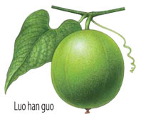 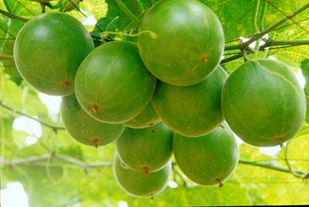

For more information, please visit [http://www.layncorp.com/](http://www.layncorp.com/?utm_source=WRBM&utm_medium=Supplier_Info&utm_content=Supplier_Info&utm_campaign=NI_FN_Websites_2012" \t "_blank) or contact us at [marketing@layn.com.cn](http://www-t.decisionnewsmedia.com/nl/jsp/mailto.jsp?email=marketing@layn.com.cn" \t "_blank) .