The Source

March 21, 2011 © 2011, PRO*ACT, LLC

Things you should know:

Honeydew extremely limited on both coasts and Nogales

Cucumber supplies out of both Nogales and Florida continue to be extremely tight

Strawberries are very limited out of California due to Heavy rains over the weekend

Eggplant from Mexico is extremely limited in availability and will be so until California begins in April



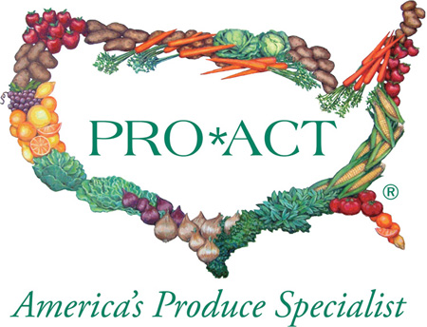

Freight: Mike McIntire
Trucks in California, Washington, and Idaho remain steady and should remain that way through out the week. Crude oil is a bit higher at $102.34. The national average continues to rise and is currently at $3.907.

Weather: Tim Lynch
A series of Pacific storm systems are lined up to impact California this week following the powerful system over the weekend currently exiting the region. This storm system over the weekend brought substantial rainfall to growing regions throughout California with Southern California especially hard hit. These systems will continue to bring rain, strong winds and cool temperatures (5-15 degrees below normal) through the week. In the desert regions the exiting storm system brought light precipitation along with cooler temperatures to the region. Temperatures in the low 70s are forecast through week as these upcoming storm system brush the area this week.

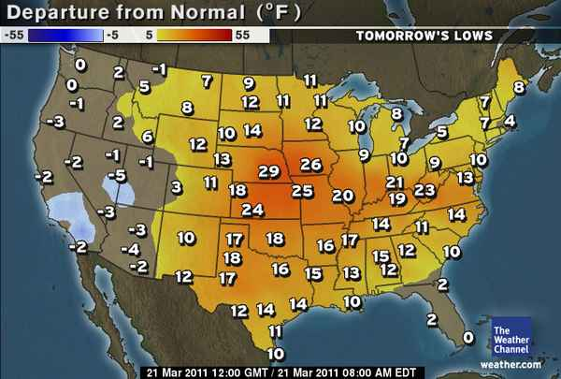
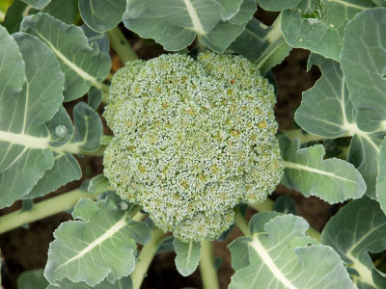

Commodity Updates

APPLES/PEARS John Tole
Washington Reds are still peaking on smaller fruit and premium color. Strong demand & lower than normal storage numbers are keeping red prices up. Many suppliers are still rationing their fruit out to ensure a year round supply. Golden delicious are still peaking on 88/100’s and larger and they are heavier to the Washington extra-fancy grade. Galas are peaking on 100/113’s and have good color. Large Gala’s remain very short! Granny-Smiths are also peaking on 88’s and larger while 100’s and smaller are extremely limited. Most shippers are subbing sizes and grades on smaller-count granny orders. Fuji’s are still high in color and continue to peak on 88’s and larger. Small Fuji’s remain very tight. D’Anjou pears are still heavier to the larger sizes and the US#1 grade. Fancy grade D’Anjou’s remain limited esp. in the smaller sizes. Small pears are really tight right now due to strong demand and light supplies. Offshore Bartlett’s are available on both coasts and are mostly in the US#1 70-110 size range. Import prices are still relatively high.

ASPARAGUS Gabe Romero/Mike Pacheco

This market is softer on all sizing. The best availability is coming on extra large and jumbos. Mexican supplies are better and California production is getting stronger out of the Bakersfield region. Peruvian product is moderate in availability on standard and large sizes. The jumbo and extra large sizing is on the light side as well.

AVOCADO Tim Kelley
Avocado supplies crossing in from Mexico continue at a lighter rate and supplies are very tight. Mexico has already packed over 70% of their crop, and has lightened their harvest to spread supplies out through the spring. The field price for the Mexican fruit keeps rising. The California crop has started packing only light numbers of their new crop. This years California crop is less than half of last years. From now through July, the industry will average only 16 to 17 million pounds in production per week. The average weekly demand runs 24 to 26 million pounds per week. The results of this shortage are and will continue to be a very strong market and much higher prices.
BELL PEPPERS Tim Kelley
Western Green Bells and Colored Bells:
Green bells out of Mexico have increased production even though they are into the tail end of their crop. There will be a few small Mexican growers starting their spring crop in early April. California’s Desert crop will start around the mid April. Colored bells are starting to lighten in production as some growers are finishing for the season and the effects of the bloom drop caused by the freeze. We expect supplies to lighten through April.
Eastern Bells: Janine Baird
The pepper market has loosened up considerably as supplies and quality improve. As Florida begins to transition northward in the coming weeks, the market should stay steady. Excellent weather throughout all the growing regions means continued good quality.

BERRIES Mike Gorczyca
Strawberries: Rain, Rain go away. California received anywhere from 3 to 6 inches of rain over the weekend. Most shippers are stripping their fields of the damaged fruit. A few are packing some light numbers for the fresh market. Quality will go downhill as this week moves on. Market is active with limited supplies. The forecast is calling for more rain on and off for the next 10 days. White shoulders, bruising, light decay and water soaked berries are some quality issues that you will see when you receive your strawberries. Mexico supplies are almost done for the season and quality of the fruit that is crossing is just fair at best. It is time to get out of this area. Florida supplies have peaked and will be slowly winding down for the season. Quality is fair out of this area. Market is firmer.
Raspberries: Market is steady with moderate supplies. Quality is being reported as good.
Blackberries: Steady supplies with good demand are causing the market to firm slightly. Quality is fair to good.
Blueberries: Good demand with lighter supplies is causing this market to firm up slightly. Supplies out of Chile are winding down. The next area to come into production is Florida which is producing some light supplies currently. Oxnard also is producing some light volume with a firm market. Quality is being reported as good. Packs are switching back to 4.4oz and 6oz. Pints are very limited.

BROCCOLI Gabe Romero/Mike Pacheco
This market is steady on bunched product as well as crowns. This week has started out a little slow in demand. Supplies are stronger in Salinas and better deals can be made if trucks can pick up direct. Current production is coming out of Yuma, Santa Maria, and Salinas. Mexico production continues to be moderate in supplies to start the week.

CARROTS Tim Kelley
California carrot supplies are very tight. Continued cool weather is slowing growth, and shippers are into their Imperial Valley carrots 3 to 4 weeks early the yields are poor. We could see this shortage go into June.

CAULIFLOWER Gabe Romero/Mike Pacheco
The cauliflower market is steady. Supplies are expected to be lighter towards the end of the week, pending demand. Production is occurring in Yuma, Salinas, and Santa Maria. Twelve counts continue to be the best in availability. There have been some reports of brown spotting upon arrivals.

CELERY Gabe Romero/Mike Pacheco
This market is firm. Suppliers have become a little tighter on all sizing, especially 30s and smaller. Currently, production is coming from Oxnard, Santa Maria and Yuma. The Oxnard production is moderate as is the Yuma production. The quality continues to get stronger in all the growing regions. Supplies look to be light to moderate later in the week.

CITRUS Tim Kelley
Lemons: Fruit sizing is shifting to 115’s and larger. The 165’s and smaller are less abundant with the market showing some firming. Heavy rains in the harvest districts are causing some uncertainty in the supplies for the end of the week. Demand remains steady.
Oranges: We are seeing the size in the orange crop starting to size up as well. The percentage of small sizes being packed is starting to drop. Just as in the lemon market supply can be impacted by the heavy rains. Pack out is currently limited to fruit in the shed.
Limes: Lime market remains very unstable. Supplies are improving and market is down. Sizing is still running to the small fruit. Expect the 150’s and larger to remain very tight.

CUCUMBERS
Western Cucumber: Tim Kelley
There are very light supplies coming out of Mexico into Nogales. Baja has begun their spring acreage and will increase weekly. Mainland Mexico will start replanted crop the first week of April.
Eastern Cucumbers: Janine Baird
With the majority of Florida’s cukes coming out
of Mexico this time of year, the cuke market remains strong. Heavy demand, scarce supply and weather related quality issues will make this a tough commodity for awhile. Prices continue to go up and quality remains marginal, at best. Florida should be back into domestics by the first part of April.

EGGPLANT
Western Eggplant: Tim Kelley
Supplies from Mexico are very limited. Production will continue to limp along until the plants the survived the freeze start to come back into production early April. The California desert will start mid April.
Eastern Eggplant: Janine Baird
Florida will be struggling with eggplant for a couple more weeks. The quality is very poor right now with scarring and soft spots prevalent on most fruit. There is a seasonal gap in eggplant out of Florida and that, coupled with limited supplies in Nogales have made for very high markets and little to no availability.

GRAPES Amy Grolnick
Flames are slim to none with only marginal quality. Crimson have started in a light way are very limited and demanding a premium price. We will not see good volume until the first week of April. Green seedless has very good availability and sizing running very big on both Thompson and Sugar Ones med/large are more limited. Red Globe and Black Seedless are both available but limited on both coasts.

GREEN ONIONS Gabe Romero/Mike Pacheco
This market is softer. Supplies are much stronger out of Mexico. Pencil sizing will be the most readily available followed by smalls and medium sizing. There have been some claims of brown bunching upon arrival. Supplies look to be good throughout this week with most suppliers.
LEAF LETTUCE Gabe Romero/Mike Pacheco
The romaine market is softer. Many suppliers are looking to move on this commodity and deals are being offered for volume orders. Yields are better and demand is off. Blister and epidermal peel is still an issue but not nearly the problem as in past weeks. Romaine Hearts have better availability and the market has come down dramatically on this commodity. Green and red leaf has come off as well. Huron has begun production and supplies look to increase next week.

LETTUCE Gabe Romero/Mike Pacheco
This market is softer. Supplies are stronger out of Yuma, and Huron has begun production. Demand is light. The quality has picked up considerably compared to past weeks. The weights and quality will vary amongst the different shippers. Yuma production has weights ranging from 36 to 42 pounds. Discoloration, and some blister have been seen upon arrivals, however the frequency is much less, in comparison to past weeks.

MELONS Amy Grolnick
Cantaloupe: Cantaloupe is still limited. Cantaloupe 9’s and 12’s are available in a light way with 15’s and smaller only available for contract business and not enough there to cover. Volume is a little more limited but quality is excellent.
Honeydew: Dews are still extremely limited on both coasts with very little fruit coming in and mostly peaking to 5ct. Small fruit is limited at best. Quality is only fair.

ONIONS John Tole
Storage yellows in the northwest continue mostly steady. Jumbos and larger are readily available but mediums are limited. Quality on the storage yellows has been good. Mexican yellows are still peaking on jumbos and colossal but are limited on mediums and their market is also steady. The quality from Mexico has also been good. Texas continues to pack a few yellows. Reds are steady in the northwest and the volume deals are still available in all areas. Mexican reds are steady. The red quality has been good on the storage reds and new crop as well. Northwest whites are steady but supplies are very limited. Mexican Whites are steady but plentiful with volume deals available on jumbos. Nevada still has all colors available and they are steady on all sizes & colors.

POTATOES John Tole
Idaho is steady on counts & number-twos and slightly lower on poly and mesh. 70’s and larger are the most limited counts. Norkotah carton prices are up again and remain very limited since most shippers only pack those one to two days per week. Idaho’s quality is mostly good although some lots have had hollow-heart and internal black spotting. Washington Norkotahs continue to vary in size. The Washington market is steady on all packs and sizes. Most Idaho & Washington shippers are packing on a limited basis to stretch their storage supplies. Colorado is also steady on all sizes and they have had more of the larger counts. Colored potatoes continue from Bakersfield and the availability is light on reds, limited on golds, and even more limited on whites. The California desert is starting now to harvest and pack now on reds and whites. Mount Vernon, Washington continues packing excellent quality reds. Washington reds will be available for the next couple weeks and their market is steady. Minnesota & Wisconsin both continue to pack reds and the market is steady but availability is light as they are nearly done. Florida continues packing limited supplies of all colors and is producing more reds than any other color, but production will increase next week.

SQUASH
Western Squash: Tim Kelley
We are seeing more new crop starting to show up in Nogales and expect supplies to increase as move through the month.
Eastern Squash: Janine Baird
Warm, dry weather has led to decent supply and good quality on squash in Florida. The market should continue to drop in the coming days.

STONE FRUIT Amy Grolnick
Offshore stone fruit is still coming in with light supplies of peaches and nectarines mostly peaking to 50’s and larger volume fill are not available. Red and black plums are both available with good quality. Cherries and
Apricots are cleaned up for the season.

TOMATOES Janine Baird
Eastern: The market continues to be high from the past freeze in Florida coinciding with the freeze in Mexico. While the quality is considerably better than the Mexican fruit, it is not close to the quality we come to expect from the Florida product. Weather, however, has been very cooperative and we should start to see improvement in the quality and supplies as well over the next few weeks. This deal will ramp up come first of April and reach its peak around the middle of April. Look for a steady market on rounds for the next couple of weeks and then it should begin to drop off.
Western: We can expect high markets and poor quality crossing from Mexico for the next 2-3 weeks. Most of the fruit has greatly reduced shelf life due to the fruit coming off stressed or dying plants. Fruit is only holding up for 3-4 days then starts popping. Eastern fruit will now be the focus of the tomato world, as Nogales product has become barely shippable.

WATERMELON Amy Grolnick
Seedless watermelon is available with limited volume, demand is light as well, and prices are steady. Seeded watermelons are still very tight with no end in sight. Quality continues to be good. The personal watermelons are in very short supply with prices up as well.

VALUE ADDED Gabe Romero/Mike Pacheco
Broccoli supplies are better this week. Cauliflower supplies will be ample to fill orders. Romaine supplies are better and the quality is picking up. The lettuce supplies have increased and twelve week averages are a thing of the past on all value-added items. Escalated pricing is finished.

Commodities at a glance…
Commodity | Quality | Market
Apples | Excellent | Steady
Asparagus | Good | Lower
Avocado (Mexican) | Good | Higher
Avocado (California) | Good | Higher
Bell Peppers (Western) | Fair/Poor | Lower
Bell Pepper (Eastern) | Good | Lower
Berries: Strawberries | Fair | Higher
Berries: Raspberries | Good | Higher
Berries: Blackberries | Fair | Higher
Berries: Blueberries | Good | Higher
Broccoli | Good | Steady
Carrots | Good | Steady
Cauliflower | Fair | Steady
Celery | Good | Steady
Citrus: Lemons | Good | Higher
Citrus: Oranges | Good | Steady
Cucumbers (Western) | Fair/Poor | Higher
Cucumbers (Eastern) | Fair | Higher
Eggplant | Fair/Poor | Higher
Grapes | Good | Higher
Green Onions | Fair | Lower
Lettuce: Leaf | Fair | Lower
Lettuce: Iceberg | Fair | Lower
Melons: Cantaloupe | Excellent | Steady
Melons: Honeydew | Fair | Steady
Onions | Excellent | Lower
Pears | Excellent | Steady
Potatoes | Good | Higher
Squash (Western) | Good | Lower
Squash (Eastern) | Fair | Lower
Stone Fruit | Good | Steady
Tomatoes (Western) | Poor | Higher
Tomatoes (Eastern) | Good/Fair | Higher
Watermelon | Fair | Steady

Commodity Updates continued

Z

Z

